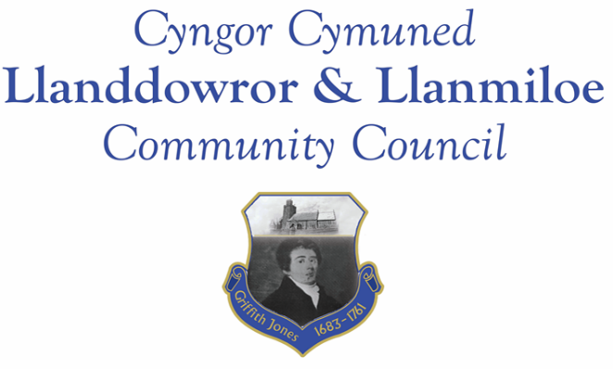

NOTICE OF MEETING

To All Members of Llanddowror & Llanmiloe Community Council.
I hereby summon you to attend the meeting of the Council, starting at 7.00pm on Monday 13th June 2022, for the transaction of the business outlined in the agenda below.

Vicky Mitchell – Clerk

Agenda

1. Apologies for absence.

2. Declaration of personal and prejudicial interests.

3. Questions from members of the public regarding items on the agenda.

4. Adoption of previous minutes – 9th May 2022.

5. County Councillor’s report, including on matters raised in previous meetings, specifically:
- Speed management issues: Llanddowror warning signs request; Llanmiloe speed bumps near school; Llanmiloe signage in village inadequate especially at night.
- Highways issues around New Mill from heavy vehicle use.

6. Clerk’s report.

7. Matters ongoing from previous minutes requiring discussions or decisions:
- Agricultural Tribunal / NRW approach – receive any update and consider any further related actions.
- Community projects – receive any new information on specific projects – those agreed were. Llanmiloe one-off pill clearance; Llanddowror seating; play equipment in both communities, Llanddowror Pocket Park tree management.

8. New business.
- Consider filling of seats remaining vacant after the election: 1 in North Ward, 2 in South Ward.
- Jubilee coin distribution for Llanmiloe Primary aged schoolchildren – decide how and by whom this will be done.
- Annual report for 2021-22.
9. Financial Report
- Current financial situation. Financial report appended to agenda.
- Income received: £0.00
- Invoices to pay:
Clerk monthly salary and expenses – June.
BLC – toilet cleaning My - £48.00
HMRC monthly payments – June.
Dwr Cymru - £20.50 (direct debit) per month..

To consider authorising payment of cleaning contract invoice at the end of each month, to be noted in the following meeting.

10. Significant correspondence.
- One Voice Wales training opportunities.
- CCC Scrutiny Committees information.
- Griffith Jones project – request for support inc applying to Parc Cynog fund for them.

Any other correspondence received prior to meeting but after the date of publication of this agenda will be brought to the attention of the meeting for consideration.

11. Planning matters.

PL/04094 - Extension to dwelling house with link to form additional bedroom - Honeywell Barn, Laugharne, Carmarthen, SA33 4RA. Consultation opened 31-5-22

Any planning received prior to meeting but after the date of publication of this agenda will be brought to the attention of the meeting for consideration.

12. Councillors’ reports or items for next meeting.

13. Date of next meeting – 12th September 2022.

~~~~~~~~~~~~~~~~~~~~~~~~~~~~~~~~~~~~~~~~~~~~~~~~~~~~~~~~~~~~~~~~~~~~~~~~~~

Meeting dates for 2022-23:

May 9th 2022
June 13th 2022
September 12th 2022
October 10th 2022
November 14th 2022
December 12th 2022
January 9th 2023
February 13th 2023
March 13th 2023
April 10th 2023
Meetings to be based in Llanmiloe Resource Centre, with hybrid access via Zoom provided as required.

