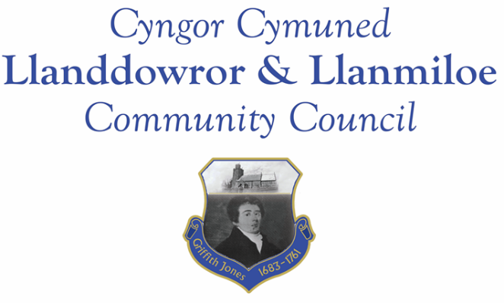

NOTICE OF MEETING

To All Members of Llanddowror & Llanmiloe Community Council.
I hereby summon you to attend a meeting of the Council, to be held at various locations from 7.00pm on Monday 8th February 2021, for the transaction of the business outlined in the agenda.

Vicky Mitchell – Clerk
AGENDA

1. Apologies for absence.

2. Declaration of personal interests.

3. Adoption of previous minutes – 11th January 2021

4. County Councillor’s report. Some matters may overlap with those listed below.

5. Matters ongoing from previous minutes.
- Bottle bank trial in Llanddowror.
- Llanddowror speed limits –GoSafe potential monitoring.
- Meeting Room water channel.
- Councillor vacancies.
- Community activities by Council, including covid-19 related activities.
- Flooding in Llanmiloe – updates, including report from Cllr Pickerskill.

6. New business.

7. Financial Report
- Current financial situation. Financial report appended to agenda.
- Invoices to pay – Clerk monthly salary and expenses.
HMRC monthly payments.
Dwr Cymru - £13.50 (direct debit)
Danfo - £84.00 – toilet cleaning
Llanmiloe covid-19 work - £119.25
Zurich – council insurance - £546.75

Council consider setting up Danfo as direct debit?

8. Correspondence.
- One Voice Wales training opportunities.
- Blue bags – due March/April – email 12-1-21

Any other correspondence received prior to meeting but after the date of publication of this agenda will be brought to the attention of the meeting for consideration.

9. Planning matters.

None received by the date of agenda publication.
Any received prior to meeting but after the date of publication of this agenda will be brought to the attention of the meeting for consideration.

10. Councillors’ reports for next meeting.

11. Date of next meeting.

