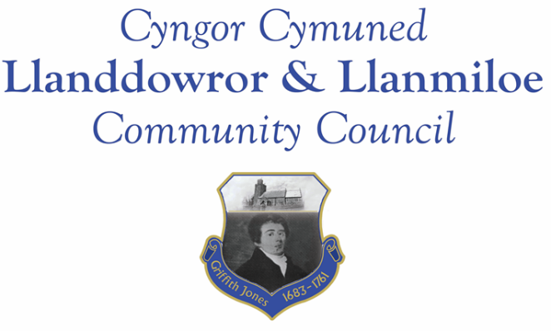

NOTICE OF MEETING

To All Members of Llanddowror & Llanmiloe Community Council.
I hereby summon you to attend the meeting of the Council, starting at 7.00pm on Monday 17th April 2023, for the transaction of the business outlined in the agenda below.
This meeting will be held in Llanmiloe Resource Centre.

Vicky Mitchell – Clerk

Agenda

1. Apologies for absence.

2. Declaration of personal and prejudicial interests.

3. Questions from members of the public regarding items on the agenda.

4. Adoption of previous minutes of meeting held on 13th March 2023.

5. County Councillor’s report, including on matters raised in previous meetings, specifically:
Sandbag containers and bag provision.

6. Clerk’s report.

7. Matters ongoing from previous minutes requiring discussions or decisions, not covered above:
- Community projects – receive any new information on specific projects – outstanding agreed one was: working with both community associations to provide play equipment in both communities.Agree payment of match funding to Llanddowror Village Association (£3500).
- Llanddowror Old Café site – consider any recent information received on planning application or enforcement process and agree any next steps to take that are available to this Council.
- Consider provision of donation to Llanmiloe School PTA to assist with costs of bike racks.
- Receive any update on alterations to Llanddowror Meeting room parking area.

8. New business.
- Community governance review – proposal to ‘unward’the Council.
- Consider purchase of replacement Council noticeboards for both villages.
9. Financial Report
- Current financial situation: Financial report appended to agenda.
- Income received:
- Invoices to pay:
- Clerk monthly salary and expenses – April.
- HMRC monthly payments – April.
- Dwr Cymru - £20.50 (direct debit) per month.
- BLC – toilet cleaning April - £64.00
- CCC – streetlight invoice for 2022-23 - £2080.40
- Audit Wales invoice for external audit 2020-21 - £333.00

10. Significant correspondence.
- One Voice Wales training opportunities.
- CCC – Community Review information.

Any other correspondence received prior to meeting but after the date of publication of this agenda will be brought to the attention of the meeting for consideration.

11. Planning matters.

PL/05526 - Removal of Condition 8 and Variation of Condition 7 on PL/02356.Abercoran Farm, Laugharne. Application registered 17-3-2023

PL/05356 - Lawful development - outbuilding bedrooms. Picton House Hotel. Llanddowror. SA33 4HJ. Application registered 26-01-2023. Application approved 17-3-2023.

Any planning received prior to meeting but after the date of publication of this agenda will be brought to the attention of the meeting for consideration.

12. Councillors’ reports for information or items for next meeting.

13. Date of next meeting – 15th May 2023. Note date change as previous agreed.

~~~~~~~~~~~~~~~~~~~~~~~~~~~~~~~~~~~~~~~~~~~~~~~~~~~~~~~~~~~~~~~~~~~~~~~~~~

Meeting dates for 2023:

May 15th 2023 12th June 2023
11th September 2023 9th October 2023
13th November 2023 11th December 2023
Meetings to be either in Llanmiloe Resource Centre, with hybrid access via Zoom provided as required, or in Llanddowror Meeting Room, or fully via Zoom.

