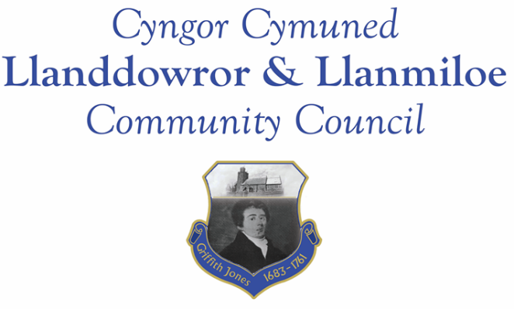

NOTICE OF MEETING

To All Members of Llanddowror & Llanmiloe Community Council.
I hereby summon you to attend meetings of the Council, to be held as hybrid meetings starting at 7.00pm on Monday 9th May 2022, for the transaction of the business outlined in the agendas below.

The first meeting will be the Annual Meeting, the second will be the normal meeting for May.

Vicky Mitchell – Clerk

Note - Incoming Councillors will be invited to sign their personal declarations of office (required before they can take office) before the start of the meeting.

Annual meeting agenda

1. Election and installation of new Chair then Vice-Chair for 2022-23. Declarations of office to be signed.

2. Apologies for absence

3. Declaration of any personal and prejudicial interests in the items listed below.

4. Address by outgoing Chair.

5. Review of annual accounts for 2021-22. Receive report of the Internal Auditor. Review the governance statements in the Annual Return – Chairman to sign the Annual Return if agreed by Council.

5. Review and re-adoption of the Code of Conduct, Standing Orders, Financial Regulations, Financial Risk Assessment and the other Policies that have been previously agreed by the Council: Welsh, Complaints, Reserves, Equal Opportunities, Dignity, Bullying and Harassment, Election and Co-option, Biodiversity.

6. Review and agree dates for normal Council meetings for the coming year. See list at the end of the agenda. Meetings to be held as hybrid meetings, in Llanmiloe Resource Centre and using Zoom as required.

Normal Meeting agenda

1. Apologies for absence.

2. Declaration of personal and prejudicial interests.

3. Questions from members of the public regarding items on the agenda. Explanation of new legislative requirement; decision by Council on process to follow.

4. Adoption of previous minutes – 11th April 2022.

5. County Councillor’s report, including on matters raised in previous meetings, specifically:
- Speed management issues: Llanddowror warning signs request; Llanmiloe speed bumps near school; Llanmiloe signage in village inadequate especially at night.
- Highways issues around New Mill from heavy vehicle use.

6. Clerk’s report.

7. Matters ongoing from previous minutes requiring discussions or decisions:
- Agricultural Tribunal / NRW approach – receive any update and consider any further related actions.

8. New business.
- Community projects – discuss circulated list and agree priorities and options; decide upon details of specific projects. Llanmiloe one-off pill clearance; Llanddowror seating; play equipment in both communities
- Election expenses forms.
- Recent passing of an individual – consider donation to Llanmiloe School as suggested by the family.
- Consider provision of Jubilee mugs for Llanmiloe school pupils.
- Llanddowror toilets.
9. Financial Report
- Current financial situation. Financial report appended to agenda.
- Income received - £4166.66
- Invoices to pay:
Clerk monthly salary and expenses – May.
HMRC monthly payments – May.
Dwr Cymru - £16.50 (direct debit) per month, increasing to £20.50 per month from 6th June.

10. Significant correspondence.
- One Voice Wales training opportunities.
- Carmarthenshire YFC – Rally invitation.

Any other correspondence received prior to meeting but after the date of publication of this agenda will be brought to the attention of the meeting for consideration.

11. Planning matters.

Any planning received prior to meeting but after the date of publication of this agenda will be brought to the attention of the meeting for consideration.

12. Councillors’ reports or items for next meeting.

13. Date of next meeting – 13th June 2022. .

~~~~~~~~~~~~~~~~~~~~~~~~~~~~~~~~~~~~~~~~~~~~~~~~~~~~~~~~~~~~~~~~~~~~~~~~~~

Meeting dates for 2022-23:

May 9th 2022
June 13th 2022
September 12th 2022
October 10th 2022
November 14th 2022
December 12th 2022
January 9th 2023
February 13th 2023
March 13th 2023
April 10th 2023
Meetings to be based in Llanmiloe Resource Centre, with hybrid access via Zoom provided as required.

