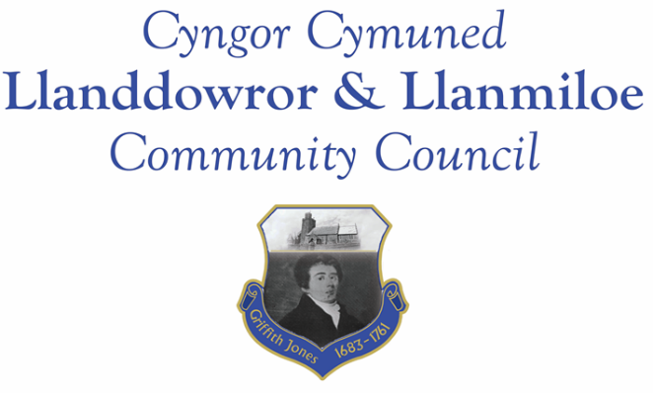
NOTICE OF MEETING

To All Members of Llanddowror & Llanmiloe Community Council.
I hereby summon you to attend the meeting of the Council, starting at 7.00pm on Monday 12th February 2024, for the transaction of the business outlined in the agenda below.
This meeting will be held in Llanmiloe Resource Centre.

Vicky Mitchell – Clerk

Agenda

1. Apologies for absence.

2. Declaration of personal and prejudicial interests.

3. Questions from members of the public regarding items on the agenda.

4. Adoption of previous minutes of meeting held on 8th January 2024

5. County Councillor’s report, including on matters raised in previous meetings including flood-related issues/measures. Queries to the County Councillor raised by those present.

6. Clerk’s report.

7. Matters ongoing from previous minutes requiring discussions or decisions, not covered above:
- Consider potential candidates to fill Council vacancies

8. New business.

9. Financial Report
- Current financial situation: Financial report appended to agenda.
- Income received: £0.00.

- Invoices to pay:
- Clerk monthly salary and expenses – February.
- HMRC monthly payments – February.
- Dwr Cymru - £50.00 (direct debit) per month.
- British Gas Lite – variable direct debit each month – £29.37 in February
- BLC – toilet cleaning February - £80.00.
- Zurich – council insurance due end March - £616.27

10. Significant correspondence.
- One Voice Wales training opportunities.
- CCC Community Review outcome – this council to be unwarded from May 2027.
- Buckingham Palace Garden Party nominations.

Any other correspondence received prior to meeting but after the date of publication of this agenda will be brought to the attention of the meeting for consideration.

11. Planning matters.

PL/07023. Installation of ground mounted solar panels and associated works - Qinetiq, Llanmiloe, Carmarthen, SA33 4UA . Application registered 9-1-2024.

PL/07070 Discharge of Condition 3 (on PL/06799)(Photographic Survey). Elim Chapel House, Llanddowror. SA33 4JA. Application registered 8-1-24

PL/04740. Siting of a static caravan adjacent to dwelling for use as overflow accommodation for dwelling house known as Cwm Curyll - Cwm Curyll, Brook School Road, Laugharne, Carmarthen, SA33 4NX Application registered 12/10/2022. Application refused 15-1-2024.

PL/06927. Certificate of Lawful Development - use of 22 caravans for residential accommodation and holiday let for people on a long term and short term. Castell Toch Caravan Site, Pendine, Carmarthen, SA33 4PX. Application registered 20-12-2023. Application decision - refusal 25-1-2024.

PL/05469. Erection of ground maintenance & machinery storage shed (in retrospect) - Land East of Llanmiloe House, Llanmiloe, SA33 4TZ. Application registered 22-02-2023. Application refused 31-1-2024

Any planning received prior to meeting but after the date of publication of this agenda will be brought to the attention of the meeting for consideration.

12. Councillors’ reports for information or items for next meeting.

13. Date of next meeting – 11th March 2024.
~~~~~~~~~~~~~~~~~~~~~~~~~~~~~~~~~~~~~~~~~~~~~~~~~~~~~~~~~~~~~~~~~~~~~~~~~~

Meeting dates for 2024-2025:

8th January 2024 12th February 2024
11th March 2024 8th April 2024
13th May 2024 10th June 2024
9th September 2024 14th October 2024
11th November 2024 9th December 2024
13th January 2025 10th February 2025
10th March 2025 14th April 2025
12th May 2025 9th June 2025
8th September 2025 13th October 2025
10th November 2025 8th December 2025
Meetings to be either in Llanmiloe Resource Centre, with hybrid access via Zoom provided as required, or in Llanddowror Meeting Room, or fully via Zoom.

