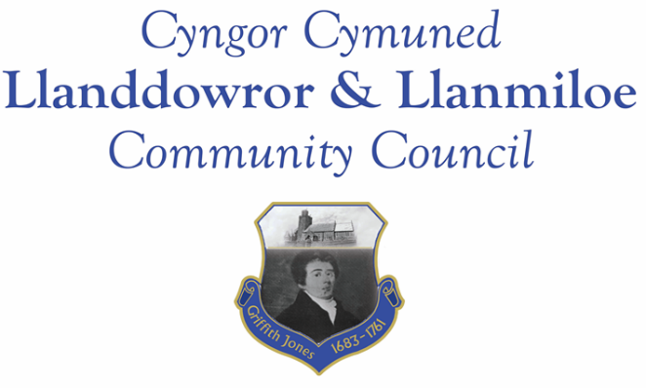

NOTICE OF MEETING

To All Members of Llanddowror & Llanmiloe Community Council.
I hereby summon you to attend a meeting of the Council, to be held at various locations from 7.00pm on Monday 8th March 2021, for the transaction of the business outlined in the agenda.

Vicky Mitchell – Clerk
AGENDA

1. Apologies for absence.

2. Declaration of personal interests.

3. Adoption of previous minutes – 8th February 2021.

4. County Councillor’s report. Some matters may overlap with those listed below.

5. Matters ongoing from previous minutes.
- Meeting Room water channel.
- Councillor vacancies.
- Community activities by Council, including covid-19 related activities any updates. To note – for CAVS grant the Council has until August 2021 to spend.
- Flooding issues in Llanmiloe – any updates.

6. New business.
- Carmarthenshire Antiquary Society – Griffith Jones legacy.
- Bwlchnewydd postbox – resident request.
- Broadband Upgrade Fund – resident request.
- Public footpath to Newton- ford issues – resident raised issue.

7. Financial Report
- Current financial situation. Financial report appended to agenda.
- Invoices to pay – Clerk monthly salary and expenses.
HMRC monthly payments.
Dwr Cymru - £13.50 (direct debit)
Danfo - £84.00 – toilet cleaning February

Unable to set up a standing order for Danfo payment due to bank account restrictions.
8. Correspondence.
- One Voice Wales training opportunities.
- Welsh Government flytipping consultation (closes 22-4-21)
- Carmarthenshire County Council Chair’s Appeal letter
- St David’s Day celebrations – Carmarthen- Friends od St Peter’s.

Any other correspondence received prior to meeting but after the date of publication of this agenda will be brought to the attention of the meeting for consideration.

9. Planning matters.

None received by the date of agenda publication.
Any received prior to meeting but after the date of publication of this agenda will be brought to the attention of the meeting for consideration.

10. Councillors’ reports or items for next meeting.

11. Date of next meeting – 12th April 2021.

