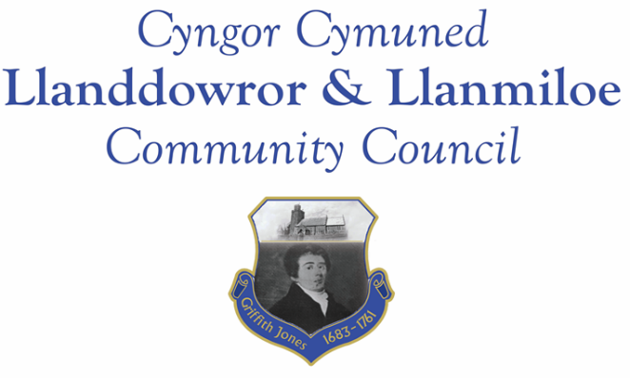

Minutes of the normal meeting of Llanddowror and Llanmiloe Community Council
Held Monday 15th May 2023.

Present Cllrs Eric Haines (meeting Chairman), David Howells, Leigh Clarkson, Sandra Hewens, Gwyn Owen, Nigel Hodson, Cllr Jane Tremlett, plus 1 member of the public.
- Apologies. These were received from Phill Pickersgill and Terence Langdon, and accepted..
- Declarations of personal interests. No interests were declared.
Cllr Jane Tremlett joined the meeting near the start of the following item.
- Questions from members of the public regarding agenda items. Cllr Tremlett agreed to seek updates on the lack of progress on the enforcement issue – there was local concern that it appeared nothing was happening, and no information being provided. Concern was also raised about the vehicles permanently parked, some of which were unlicensed – she would raise this with the police in her next meeting with them later in the month, and also mention the continued speeding through the village.
- Adoption of previous minutes for the normal meeting on 17th April 2023. These were agreed by all, and duly signed by the Chairman.
- County Councillor’s report: County Cllr Tremlett stated that she expected a grit bin to be located by the Meeting Room very soon. Sandbags were not currently available, but she would chase up the removal of the dangerously rusty sandbag bin near Pocket Park and its replacement to go by the Meeting Room. It was pointed out that sandbags need to be available possibly at short notice in the community.
Cllr Tremlett also agreed to use the County Councillor DSU system to chase up actions promised at and after the site meeting last September regarding the blocked pills, overhanging trees, obscured streetlight and school footpath lighting in Llanmiloe.
It was also stated that the Coastal Path had not had grass cut this year. In addition the road between New Mill and Three Lords had seriously deteriorated to the point the potholes and edge drop-offs were a hazard to vehicles.
- Clerk’s report. The Clerk had previously circulated the report and provided verbal updates on the various matters. She would chase up on ongoing matters.
- Matters ongoing from previous minutes:
- Llanddowror Old Café site. There was no update to provide – it was with the planning enforcement Officer to send the enforcement notice. Cllr Tremlett would seek information on the timescales for this.
- Donation to Llanmiloe School PTA. The PTA was keen to support the provision of swimming lessons for pupils. It was agreed to donate £300.00 toward the cost of transport for this to take place.
- New business:
- Co-option. A potential candidate had been identified – the Clerk would contact her to see if she was interested.
- Bank mandate update. Two new signatories were agreed. It was also agreed to aim for online payments as the default for the Council were possible, for convenience accountability and efficiency. The Financial Regulations changes required for this had been discussed and agreed in the annual meeting. The Clerk would proceed with this.
- Llanddowror Meeting Room redecoration. Quotes had been requested, and two had been received. These were reviewed, and it was agreed to appoint one contractor for the work. The Clerk would inform them accordingly.
- Llanmiloe School – additional community governor. One candidate had come forward – it was agreed to nominate this known individual to the role. The Clerk would inform the Head teacher accordingly.
- Code of Conduct training. The Clerk had circulated information on some training being run by CCC. No Councillor expressed a wish to attend the training sessions, but they would all review the training materials sent out afterwards.
9. Financial Report
The current financial situation was provided to all Cllrs.
- Income received: £ 4500.00 – first tranche of the precept; £115.12 – Swalec credit – part of the Govt cost of living help provision.
- Invoices to pay:
- Clerk monthly salary and expenses – May.
- BLC – toilet cleaning May - £64.00.
- HMRC monthly payments – May.
- Dwr Cymru - £20.50 (direct debit) for May, rising to £50.00 a month from June. This was possibly due to the water leak earlier in the year.
- Llewelyn Davies internal audit for 2021-22 - £300.00
- We can source it ltd – toilet rolls - £22.79
- Llanmiloe School PTFA - £300.00 donation towards transport for swimming lessons.

10. Significant correspondence.
- One Voice Wales training opportunities. These were noted.

11. Planning matters.
PL/05929 – Proposed parking area – Llanmiloe School. Application registered 4-5-2023. There were no objections.

12. Councillors’ reports for information or items for next meeting.
The Council was thanked by both Llanddowror Village Association and Llanmiloe and Disctrict Community Association for the donations towards their coronation events.
Cllr Hewens mentioned that there had been fewer invitations to support local events during the last year than in years gone by. Covid-19 was considered possibly a cause as habits had changed.
Cllr Haines expressed his thanks and those of the whole Council to Cllr Hewens for all her work during her Chairman’s year – it had been very much appreciated.
13. Date of next meeting – 12th June 2023.
There being no further business the meeting concluded at 8.45pm

