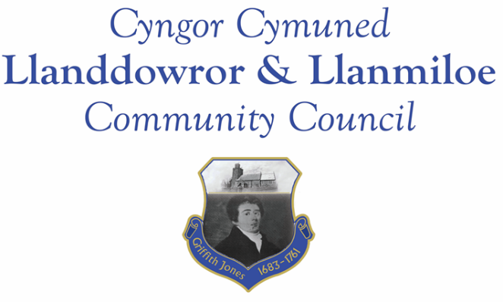
Minutes of the normal meeting of Llanddowror and Llanmiloe Community Council
Held in the various locations via Zoom, Monday 12th October 2020.

Present Cllrs Terence Langdon, Chris Holt, Gwyn Owen, Phill Pickersgill, David Howells and County Cllr Jane Tremlett.
Cllr Langdon was delayed in joining the meeting, and so those present elected Cllr Holt to Chair the meeting until he arrived.
Apologies. These were received from Cllrs Sandra Hewens and Nigel Hodson. Their reasons for absence were accepted.
Declarations of personal interests. There were none received.
Adoption of previous minutes. The minutes of the meeting of 14th September had been previously circulated. The minutes were accepted as a true record and would be duly signed at the earliest opportunity – proposed Cllr Owen, seconded Cllr Howells and agreed by all.
County Cllr’s report. County Cllr Tremlett stated the Pendine Tourist Attractor Project would be completed next year, probably by early summer, and so she would ask that the whole road from the quarry turn off near Laugharne through to Pendine be thoroughly examined and that the whole stretch be resurfaced throughout prior to the opening. This was discussed and it was agreed by the whole Council when put to a vote that they were in full support of this, because they had ongoing concerns about the road surface and the negative impact the project traffic was having upon it.
She stated that she has as yet been unable to get a narrative commentary on the traffic speeding repot for Llanddowror, but if the residents of the village were in favour of reducing the speed through the village to 20 mph she would put that proposal forward. This was discussed and it was stated that residents were in favour, had been trying to progress this for over two years, and that there were still speeding issues after the bypass, so something needed to be done. This was put to a vote and all Councillors present agreed it as a resolution of the Council.
Matters ongoing from previous minutes:
- Meeting Room water channel. The contractor had responded, and so the Clerk would work on finally getting the channel sorted.
- CAVs post-covid-19 re-opening funding. The Clerk reminded those present that this funding included some provision for recompense for out of pocket expenses incurred by local residents whilst helping others at this time. Anyone who considers this might apply to them should contact the Clerk.
- Councillor vacancies. The meeting was reminded of the current vacancies, and potential candidates would continue to be sought.
Cllr Tremlett left the meeting at this point. Cllr Langdon joined the meeting and took on the duties of Chairman.
New business:
- Appointment of Vice-Chairman. This was briefly discussed, but no appointment made.
- Community activities and actions to raise the profile of the Community Council. This was discussed, and it was agreed to look at any opportunities that arose that could benefit the communities the Council served. The Clerk had received a letter from a local informal group in Llanddowror asking whether they could assist with the seating in Llanddowror Pocket Park. It was agreed by all after discussion to fund three seats from Council monies and donate them to the group. The Clerk would liaise with the group regarding this.
- Remembrance events and wreath laying. Correspondence had been received from the local RBL branch regarding proposed events. It was agreed that this was a difficult year, and accepted that the normal services would be different. After discussion it was proposed that the Council forgo actually having and laying wreaths this year, but that they be mentioned during the service at the War Memorial. In addition it was agreed to increase the donation to the RBL from the Council to £100.00 since they would be lacking their other normal forms of collection. The Clerk would arrange this.
Financial report:
An up to date report on the finances of the Council had been previously circulated. The Clerk also stated that the Council should shortly be receiving £225.00 from the Welsh Government to cover lost income for the Meeting Room between April and June this year.
The following invoices were noted, and agreed for payment – proposed by Cllr Howells, seconded by Cllr Holt and agreed by all:
- Clerk monthly salary and expenses.
- Clerk monthly tax due.
- Dwr Cymru direct debit £13.50 monthly
- Danfo – toilet cleaning contract - £168.00
Correspondence
Items of correspondence since the last meeting had been forwarded upon receipt. Specific items to note were:
- St Peter’s Church – they were holding their Christmas Fayre online this year – details would be circulated when they were received.
- One Voice Wales online training. Although no Cllrs were currently interested in attending this, they wished to continue to receive the information.
- IRPW draft report – this was noted.
Planning matters:
Planning application PL/00339. Single storey extension o front elevation 52 Llanmiloe Estate. This was examined in detail online and discussed. There were no objections, so the Clerk would inform CCC accordingly.
Planning application W/40767 – revised and amended details. This was considered, and it was agreed that the Council still objected on the grounds given in their earlier response. The Clerk would inform CCC accordingly.
Councillors’ reports for next meeting.
There were no issues raised.
Date and venue of next meeting
The next meeting was planned for November 9th, most probably via Zoom, depending upon Government restrictions. The Clerk would call a meeting beforehand if it was required.
There being no further business the meeting concluded at 8.15pm.

