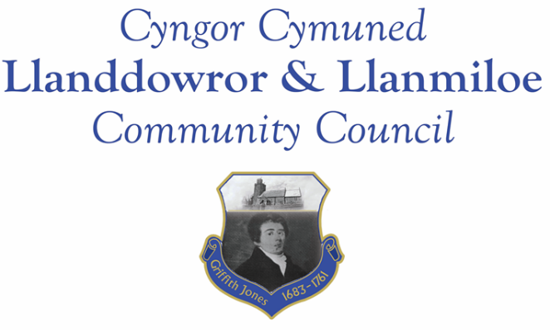

Minutes of the normal meeting of Llanddowror and Llanmiloe Community Council
Held in Llanmiloe Resource Centre and via Zoom, Monday 13th June 2022.

Present Cllrs, Sandra Hewens (Chairman), Gwyn Owen, David Howells. Terence Langdon, Eric Haines, County Cllr Jane Tremlett.
- Apologies. There were apologies received from Nigel Hodson and Phill Pickersgill
- Declarations of personal interests. No interests were declared.
- Questions from members of the public regarding agenda items. There were no members of the public in attendance.
- Adoption of previous minutes for the Annual Meeting and normal meeting on 9th May 2022. These were agreed by all, and duly signed by the Chairman.
- County Councillor’s report: County Cllr Tremlett provided an update from CCC officers regarding the various speeding concerns that had been raised. An inspection of the lighting and traffic control measures appropriate under current legislation for Llanmiloe would be done and reported back to this Council. She also verbally summarised the changes due to reduce default speeds Wales-wide in most built up areas to 20mph, and the requirement on CCC to assess the 50 more rural wards including over 200 villages for this. There would be a public consultation taking place between July and September this year. CCC, it was stated, had no powers to monitor or enforce speed limits – that was for the police and GoSafe.
Cllrs highlighted to Cllr Tremlett that the requirement to prove accidents or risk before any speed limits were reduced was impossible when the requests to GoSafe to monitor and gather that data were ignored, because they had no statistical evidence of speeding, although there was plenty of anecdotal evidence available from local residents regarding vehicle near misses, pedestrian danger and pet fatalities.
It was agreed that both the Council and Cllr Tremlett would write to the Police and Crime Commissioner highlighting the issues.
Cllr Tremlett stated she had asked for the verges to be cut on the A4066 near to the school for safety. She stated there was no specific concerns from the school regarding speeding vehicles passing the entrance, but she had asked CCC officers to do a survey on traffic speeds, and also improve the road marking and signage in that area.
CCC officers had yet to respond regarding the three Llanddowror speed warning sign locations – this should happen by 17th June.
Cllr Tremlett stated that all the rural roads in Carmarthenshire faced the same problems of ever-heavier HGV vehicles that were damaging verges and the highways infrastructure. If the business being carried out was legal, then the traffic could not be prevented. It was raised on this point that 16/17 year olds are driving some of these vehicles which can give rise to safety concerns.
Queries were then raised with Cllr Tremlett: She stated that Pendine Council was due to have some Cllrs in the near future after the May election resulted in no nominations. She stated she would request that the Coastal Path invading shrubbery be trimmed back to enable the path to be used safely, and contact Qinetiq regarding the plants and trees growing through the fencing. Finally the enforcement issue in Llanddowror was raised – she stated she would follow up to get this progressed more quickly..
Cllr Tremlett left the meeting at this point.
- Clerk’s report. The Clerk had previously circulated the report with any relevant updates. It was agreed that summary timelines could be produced to record the lack of progress on various topics of concern.
Cllr Owen left the meeting at this point.
- Matters ongoing from previous minutes:
- Agricultural Land Tribunal. There was no update to provide – a contact with NRW would be forthcoming as soon as possible.
- Community projects – An indicative quote had been sought for the pill clearance; potential play equipment options had been circulated. The limitations of the funding available were explained – that it came from the precept not from any external grant and so was not an automatically renewable funding stream. More information would be circulated and discussed in the next meeting.
- New business:
Community projects:
- Vacant Council seats. This was discussed and it was agreed to approach potential candidates over the summer and bring forward candidates in the September meeting.
- Jubilee coin distribution. The Clerk stated some dates the School had suggested and the preferred date and time was agreed. The Chairman and Clerk would attend.
- Annual report for the council 2021-22. This had been previously circulated and was agreed with one minor alteration. This would be published on the Council website within a week.
- Financial report:
An up to date report on the finances of the Council had been previously circulated, and was discussed..

The following invoices were noted, and agreed for payment by all:
- Clerk monthly salary and expenses - June.
- Clerk monthly tax due – June.
- Dwr Cymru direct debit £20.50 monthly.
- BLC – Llanddowror toilet cleaning - £48.00

It was agreed that the toilet cleaning invoice should be paid upon receipt at the end of each month and noted in the minutes of the next meeting.

- Significant correspondence
- One Voice Wales training opportunities. These were noted.
- CCC Scrutiny Committee information. This was noted.
- Griffith Jones project. This woas noted and it was suggested that it would be more appropriate to be passed on to Llanddowror Village Association for ocnsideration.

- Planning matters:

PL/04094. Extension to dwelling house with link to form additional bedroom. Honeywell Barn, Laugharne, Carmarthenshire. SA33 4RA. There werew no objections to this application.

- Councillors’ reports of issues and items for next meeting.
Residents in
were welcome.
- Date and venue of next meeting
The next meeting was planned for September 12th 2022. It was agreed to plan to have this in person in Llanmiloe Resource Centre with remote access enabled for those who wished it.
There being no further business the meeting concluded at 9.00pm.

