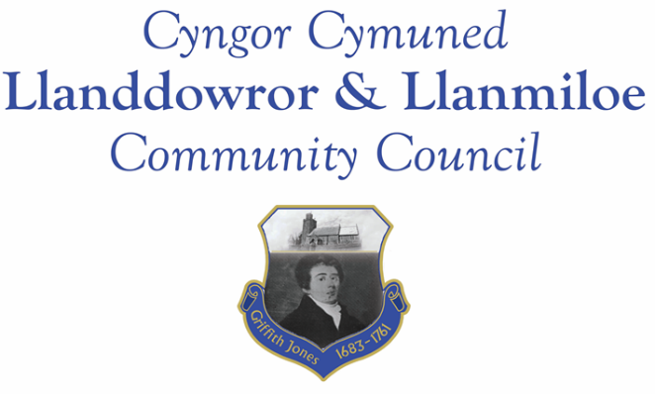
Minutes of the normal meeting of Llanddowror and Llanmiloe Community Council
Held in the various locations via Zoom, Monday 14th February 2022.

Present Cllrs David Howells (Chairman), Sandra Hewens, Terence Langdon, Gwyn Owen, Eric Haines, County Cllr Jane Tremlett.
Apologies. There were apologies received from Cllrs Pickersgill and Hodson.
Declarations of personal interests. No interests were declared.
Adoption of previous minutes. The minutes of the meeting of 10th January had been previously circulated. The minutes were accepted as a true record, and so would be duly signed at the earliest opportunity.
County Cllr’s report. County Cllr Tremlett stated that the budget and plans for 2022-23 was a key topic in CCC at the moment. She also spoke about the Carmarthenshire local environmental quality plan which would set response times for various reported safety issues such as fly tipping, dead animals, graffiti etc. This would be publicised once adopted by full Council. Cllr Tremlett was asked whether she could get the coastal path properly cleared where it went between the trees opposite the old Social Club because it was slippery and rapidly becoming overgrown from both sides. It was pointed out it was not only the coastal path used by tourists, but also a designated cycle route and used a lot by the local community as an amenity.
It was also raised that there needed to be speed reduction measures near the school for safety reasons. Cllr Tremlett would raise this with the relevant departments. It was pointed out that the school was not sufficiently signposted as a potential danger spot for traffic, and was now larger so there was an increase in both traffic and pedestrian numbers that were being put at risk. The signage for the speed bumps within the village being in the wrong location and so insufficient was again raised.
Cllr Tremlett then left the meeting.
Matters ongoing from previous minutes:
- Agricultural Land Tribunal. The Clerk updated the meeting on the discussions she had had with affected land owners. It was agreed to seek a meeting with NRW regarding the issues as a next step. Cllr Owen joined the meeting during this item.
- Meeting Room water channel and door. This had now been completed, and the invoice for the work carried out had been received. It was agreed to pay it. The possibility of offering the car park area to GoSafe for monitoring was discussed briefly but it was considered unsuitable because it was not on the main road which was where the speeding occurred..

New business:
- A motion was put forward and agreed to exclude any press and public from this item on the grounds it was likely to include personal information. The Clerk left the meeting at this point after making a brief statement. The Clerk’s salary rate was discussed by all. The Clerk was called back into the meeting and offered an increase to scp23, which was accepted.
- It was agreed that press and public could be re-admitted to the meeting.
- Llanmiloe seat. It was discussed and agreed that a new seating bench would be purchased by the Council, to include a plaque to commemorate Cllr Holt and his work in the community. It was also agreed for parity to offer a seat to Llanddowror for public use – the Clerk would work with the Village Association to agree a suitable seating bench and order it. The purchase of flowers the previous month by the Clerk for the family of Chris Holt was agreed unanimously.
- Donation requests. The Clerk informed the meeting of a request from Wales Air Ambulance Appeal (also the chosen charity for the Carmarthenshire Chairman) and also a suggestion of Whitland Foodbank. It was agreed to donate £50.00 to each, using the remainder of the donations budget with a top-up from the Chairman’s budget.
Financial report:
An up to date report on the finances of the Council had been previously circulated, and was discussed.
The following invoices were noted, and agreed for payment by all:
- Clerk monthly salary and expenses - February.
- Clerk monthly tax due – February.
- Dwr Cymru direct debit £16.50 monthly
- Swalec – quarterly direct debit for Meeting Room - £34.97
- Chris Thomas – work on Meeting Room water channel and door - £725.00
- Zurich – Council’s insurance - £564.25
Significant correspondence
- One Voice Wales training opportunities.
- Buckingham Palace Garden Party invitation.
- ‘Fair election’ pledge for May 2022.
- Welsh Water draft water resources management plan 2024.

Planning matters:
PL/40767 – Phase 2 tourism development of 6 log pods with linked garden enhancements. Land at Llanmiloe House, Llanmiloe. SA33 4TZ Planning decision – full refusal 12-1-22.

PL/033347 - Planning application - Discharge of condition 3 on W/38608 (Archaeological written scheme of investigation). Deers Park Farm, Laugharne, Carmarthen, SA33 4RG. Application registered 20-1-2022. Application granted 2-2-2022

PL/03026 Planning application – new house – 4 bed detached - 3 Dan Y Bryn, Pendine, Carmarthen, SA33 4EZ. Application granted 8-2-22

Councillors’ reports of issues and items for next meeting.
A query arose regarding the ownership and responsibility for the land between the boundaries put in place by the Dan Y Bryn houses and the road edge. The Clerk would investigate and report back, contacting the developer as necessary.
A query was also raised regarding work carried out on a house in Llanmiloe – the Clerk would investigate and report back.
It was reported that the speedbumps within Llanmiloe were not adequately marked for night-time traffic – white line markings or illumination as in Pendine was suggested. The Clerk would raise this with CCC.
Date and venue of next meeting
The next meeting was planned for March 14th 2022, with it being decided nearer the time whether to hold it in Llanmiloe Resource Centre or by Zoom.

There being no further business the meeting concluded at 8.20pm.

