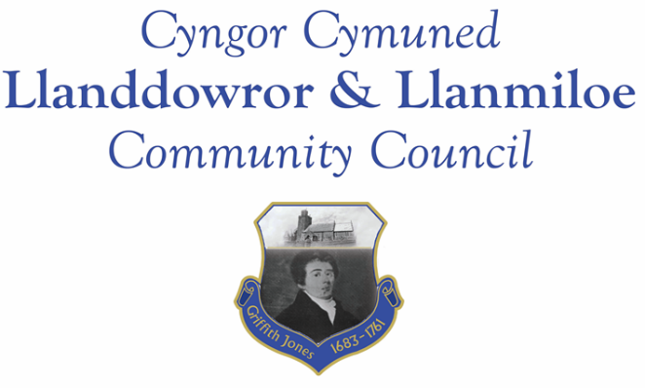
Minutes of the normal meeting of Llanddowror and Llanmiloe Community Council
Held in the various locations via Zoom, Monday 12th April 2021.

Present: Cllrs Terence Langdon, Sandra Hewens, David Howells, Chris Holt, Gwyn Owen, Phill Pickersgill, Catrin Davies and County Cllr Jane Tremlett, plus one member of the public.
The meeting started at 7.10pm after some technical difficulties for Cllr Langdon. Cllr Hewens had further difficulties in the second half of the meeting.
The meeting started with a minute’s silence from all out of respect for the recent death of His Royal Highness, The Prince Philip, Duke of Edinburgh.
Apologies. These were received from Cllr Nigel Hodson.
Declarations of personal interests. Cllr Davies declared a personal interest in the Meeting Room water channel item.
Adoption of previous minutes. The minutes of the meeting of 8th March 2021 had been previously circulated. The minutes were accepted as a true record and would be duly signed at the earliest opportunity – proposed Cllr Holt, seconded Cllr Pickersgill and agreed by all.
County Cllr’s report. Cllr Jane Tremlett stated that she had received apologies from the relevant Director regarding the delayed response to the flooding report provided by the Council. The concerns would be investigated and a comprehensive response would be provided as soon as possible. The Council were assured that CCC were taking the matter seriously.
The GoSafe order had been received for Llanddowror, but staffing issues had caused delays. It was suggested that the Clerk follow up on this and liaise with Cllr Tremlett as necessary.
Matters ongoing from previous minutes:
- Meeting Room water channel. One quote had been received for the work, which was discussed. Other contractors had been approached, but had either declined to quote or not responded. It was agreed to accept the quote and have the work completed. The Clerk would contact the contractor accordingly.
- Councillor vacancies. Councillors agreed to keep seeking potential candidates, and would pass their details on to the Clerk with permission.
- Flooding in Llanmiloe. This had been largely covered in the County Councillor’s section. In addition Cllr Tremlett stated that under the Highways Act if it was proved that activity had diverted water to the detriment of a highway (e.g. causing dangerous flooding) then enforcement could be instigated by the authorities.
- Broadband Upgrade Fund. The Clerk updated the Council on the correspondence she had had.
- Bwlchnewydd postbox. The Clerk updated the Council on the correspondence she had received.
- Litter picker kit. The Council had been successful in obtaining kit from Keep Wales Tidy. It was agreed to split it equally between the two Wards. The Clerk would pass on the kit, and usage instructions, to Cllrs Langdon and Howells for local use as soon as possible. A Llanmiloe resident was cited as undertaking exemplary work litter-picking locally – the Council were all in favour of sending a letter of thanks and appreciation. Cllr Tremlett stated that if there were particular areas of high littering these should be reported to CCC even if they were then cleared, so that a good understanding of places of concern could be obtained.
New business:
- Request for support for bin outside Llanddowror Pocket Park. The Clerk provided the background to this. After discussion it was agreed to support the provision of a public bin by CCC. Cllr Tremlett stated she would also support the provision. The Clerk would write to CCC.
- One Voice Wales subscription renewal. This was briefly discussed and the Council agreed to it for another year. The Clerk would respond accordingly.
- OVW/SLCC joint conference May 2021. The Clerk provided brief information on this. It was agreed after brief discussion to support and pay for the Clerk to attend. The Clerk would respond accordingly.
- Carmarthenshire Antiquary Society – Griffith Jones legacy – request for support. Cllr Howells stated that there were events going ahead in Llanddowror for this. It was agreed that the Council supported the work being done. The Clerk would respond accordingly.
- Llanmiloe flytipping opposite the old social club. Garden waste was again being dumped here as last year. It had been reported to the relevant CCC department in March. It was agreed that if necessary measures to clear the area would be taken and signage put up to remind residents not to fly tip waste.
- National Library of Wales web-archive. The NLW had asked permission to web-archive the Council’s website. The Council was in favour of this happening – the Clerk would advise NLW accordingly.
Cllr Owen and County Councillor Jane Tremlett left the meeting at this point. It was agreed that any issues to raise with Cllr Tremlett from the rest of the meeting would be passed on by the Clerk.
- Llanddowror development work in village. The Council was updated on the current situation regarding this development work, about which some residents had raised concerns.
Financial report:
An up to date report on the finances of the Council had been previously circulated, and was accepted as accurate.
The following invoices were noted, and agreed for payment – proposed by Cllr Holt, seconded by Cllr Howells and agreed by all:
- Clerk monthly salary and expenses.
- Clerk monthly tax payment.
- Dwr Cymru direct debit £13.50 monthly.
- Danfo – toilet cleaning contract - £84.00 for March.
- CCC – streetlights for 2020-21 - £2764.23. The Clerk would chase up on whether this charge included the loan repayment. She confirmed that the invoice was approximately £200 less that 2019-20.
Correspondence
Items of correspondence since the last meeting had been forwarded upon receipt. Specific items to note were:
- One Voice Wales remote training opportunities in April. This was noted.
- Welsh Government consultation on General Power of Competence and Power to trade for local councils. This was noted.
- Welsh Government publication of compulsory purchase order manual. This was noted.
- Natural Resources Wales 2021 refresh of the Countryside Code. This was noted.

Planning matters:
PL/01365. Dwelling house and detached garage (reserved matters to W/38336). 28 Dan Y Bryn, Pendine. SA33 4EZ. Application received 9-3-21. There were no objections.

PL/01492. Two storey side extension. Brook Cottage, Brook School Road, Laugharne. SA33 4NX. Application received 18-3-21. There were no objections.

PL/01256. Reserved Matters to Outline Planning Permission W/38336 - 20 Dan y Bryn, Pendine, Carmarthen, SA33 4EZ Application received 30-3-21. There were no objections.

PL/01495. Reserved Matters Application to Outline Planning Permission W/38336 for Construction of house - 21 Dan Y Bryn, Pendine, Carmarthen, SA33 4EZ Application received 30-3-21. There were no objections.

PL/01632. Resubmission of a granted planning permission (W/33688) for a double storey extension. Tyr Felin, Llanddowror, Carmarthen, SA33 4HJ Application received 1-4-21 [W/33688 granted in 2016]. There were no objections.

W/39885. Construction of two storey extension and detached garage/equipment store. Cwnc, Llanddowror. SA33 4HN. Application granted 9-3-21

Councillors’ reports for next meeting.
Cllr Holt raised concerns he had received from residents in Llanmiloe about the new parking regime in the Pendine Car Park. Whilst fully accepting that it was a matter for Pendine Community Council as the owners, he suggested that this Council could approach them to see if any leeway for Llanmiloe residents be included, considering the closeness of the two communities. Cllr Langdon supported this viewpoint. After discussion the Clerk suggested that she could contact the Pendine Clerk to ascertain the situation and bring back information to the Council for the next meeting for consideration.
Date and venue of next meeting
The next meeting was planned for 10th May 2021, most probably via Zoom. The Clerk would call a meeting beforehand if it was required.
There being no further business the meeting concluded at 8.05pm.

