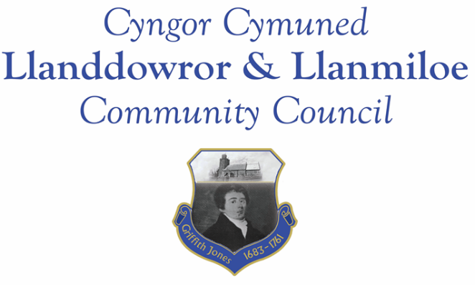

NOTICE OF MEETING

To All Members of Llanddowror & Llanmiloe Community Council.
I hereby summon you to attend the meeting of the Council, starting at 7.00pm on Monday 14th November 2022, for the transaction of the business outlined in the agenda below.
This meeting will be held in Llanddowror Meeting Room, unless Zoom access is requested.

Vicky Mitchell – Clerk

Agenda

1. Apologies for absence.

2. Declaration of personal and prejudicial interests.

3. Questions from members of the public regarding items on the agenda.

4. Adoption of previous minutes of meeting held on 3rd October 2022.

5. County Councillor’s report, including on matters raised in previous meetings, specifically:
Sandbag containers and bag provision; site meeting for Llanddowror enforcement issue.

6. Clerk’s report.

7. Matters ongoing from previous minutes requiring discussions or decisions, not covered above:
- Community projects – receive any new information on specific projects – those agreed were. Llanddowror seating; play equipment in both communities, Llanddowror Pocket Park tree management.
- Llanddowror Old Café site – consider any recent information received on enforcement process and agree next steps to take that are available to this Council.
- Council vacancies – consider suitable candidates – 1 North Ward, 2 South Ward.
- Receive any feedback on Llanddowror Meeting Room donations box.

8. New business.
- Consider supporting potenital LCDA / LVA grant application to Parc Cynog – decide match funding level to offer.
- Consider requesting CCC replace speed cushions through Llanmiloe with round ones.
- Consider requesting CCC install round speed cushions through Llanddowror.
- Consider formaqlly requesting streetlights or other suitable illumination for the A477 Llanddowror junction – both start of the pull off and at the actual junction.
9. Financial Report
- Current financial situation. Acknowledgement of national pay agreement for 2022-23 year. Financial report appended to agenda.
- Income received:.
- Invoices to pay:
- Clerk monthly salary and expenses – October and November.
- BLC – toilet cleaning October and November- £64.00 and £tbc.
- HMRC monthly payments – October and November..
- Dwr Cymru - £20.50 (direct debit) per month.
- Swalec - £41.42 on 31-10-22 – direct debit.

10. Significant correspondence.
- One Voice Wales training opportunities.

Any other correspondence received prior to meeting but after the date of publication of this agenda will be brought to the attention of the meeting for consideration.

11. Planning matters.

PL/04740 - Siting of a static caravan adjacent to dwelling for use as overflow accommodation for dwelling house known as Cwm Curyll - Cwm Curyll, Brook School Road, Laugharne, Carmarthen, SA33 4NX Application registered 16/10/2022.

PL/04886 - Proposed new parking area in Llanmiloe school - Llanmiloe Cp School, Llanmiloe, Carmarthen, SA33 4TU. Application registered 12/10/2022.

PL/04972 - Proposed erection of a single new dwelling on an existing and on-going residential development site - Plot 9, land adj to Wood End, Llanmiloe, Pendine, SA33 4EZ. Application registered 1-11-2022.

Any planning received prior to meeting but after the date of publication of this agenda will be brought to the attention of the meeting for consideration.

12. Councillors’ reports for information or items for next meeting.

13. Date of next meeting – 12th December 2022.

~~~~~~~~~~~~~~~~~~~~~~~~~~~~~~~~~~~~~~~~~~~~~~~~~~~~~~~~~~~~~~~~~~~~~~~~~~

Meeting dates for 2022-23:

December 12th 2022
January 9th 2023
February 13th 2023
March 13th 2023
April 10th 2023
Meetings to be either in Llanmiloe Resource Centre, with hybrid access via Zoom provided as required, or in Llanddowror Meeting Room, or via fully Zoom.

