Annual Report for Llanddowror and Llanmiloe Community Council 2021-22
Background
Llanddowror and Llanmiloe Community Council is the tier of local government that is closest to the communities and people that it serves, and it is focussed specifically on the interests and concerns of the people who live or work in Llanddowror, Llanmiloe and the various farms, businesses and within the area that it covers.
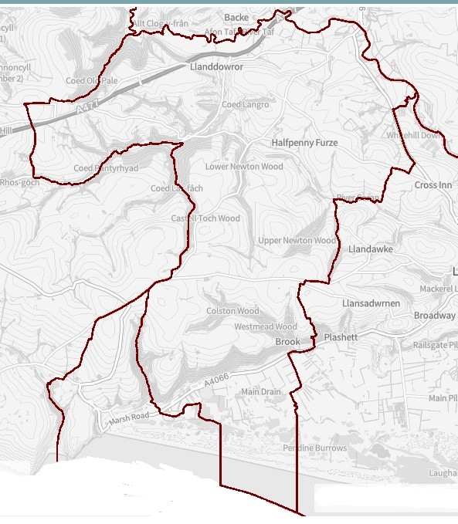
The Council is composed of ten Councillors, five from the South Ward focussed on Llanmiloe and five from the North Ward focussed on Llanddowror. These are elected to that position every five years by people in those wards. The Council works closely with the two thriving village associations that are very active in their communities. The Council has one part-time employee, the Clerk / Responsible Financial Officer.
In Llanddowror itself Llanddowror and Llanmiloe Community Council owns and runs the Meeting Room, and also the public toilets that are adjacent to it. In Llanmiloe the Llanmiloe and District Community Association own and run the Resource Centre, as well as the adjacent playing field.
Priorities
Our priorities are to support the people we serve and to enhance the area in which they live and work. To do this we work with other bodies such as Carmarthenshire County Council, Carmarthenshire Association of Voluntary Services, Bro Myrddin Housing Association, Qinetiq, Natural Resources Wales, Llanmiloe and District Community Association, Llanddowror Village Association, for instance.
The Council has neither the resources nor the legal ability to cover or manage everything that it is asked to do, and as the local Council we are sometimes expected to deal with things which are actually the responsibility of another body. We do our best though! Examples include fixing broken streetlights, sorting out potholes or road damage, or dealing with flytipping. When this happens, the request is passed on to the relevant body, and we will let you know.
We are always open to new ideas of how we can support and help you, and assure you we will do what we can, so please do get in touch via the Clerk – contact details at the end.

Activities and Achievements
Right at the start of 2021 we were pleased to be able to support you all in the ongoing covid-19 situation by providing some seating benches for people to use. We recognised that being able to participate in exercise outside, and being able to meet people outside, were absolutely essential to the mental and physical health of people during the ongoing pandemic, and were well aware of how important the open spaces available in both villages had been to this activity. This came about through a query to the Clerk – and we were delighted to be able to help in this way.
Therefore, three seats were bought and placed in the Pocket Park in Llanddowror, and three more at the edge of the football field in Llanmiloe.
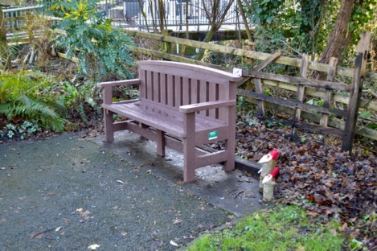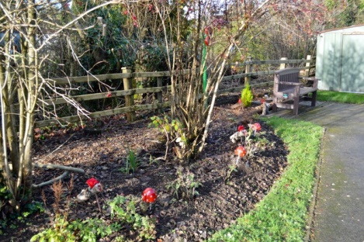
In the spring of 2022 we then provided three new waste bins to go around the football field in Llanmiloe. These replaced ones that were old and rusting, and were also too small for the amount of waste that they needed to hold. A large number of people use the Coastal Path that runs through Llanmiloe for personal exercise and for dog-walking, whether locals walking westwards from Brook, or eastwards from Pendine, or the many many tourist and day visitors that come to this area between Easter and October.
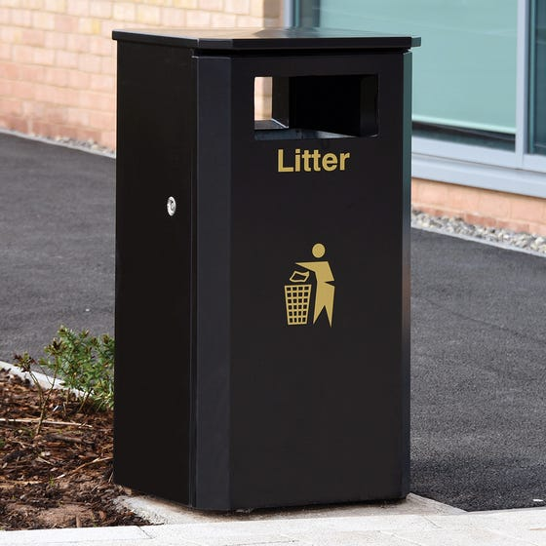
In the spring of 2022 the Council also provided more seating in both communities – one seat was bought and placed in the Old Pound in Llanddowror, and another seat placed at the edge of the football field in Llanmiloe. This last seat was placed in memory of the sad death of a Councillor – Chris Holt, who passed away from cancer during the year.

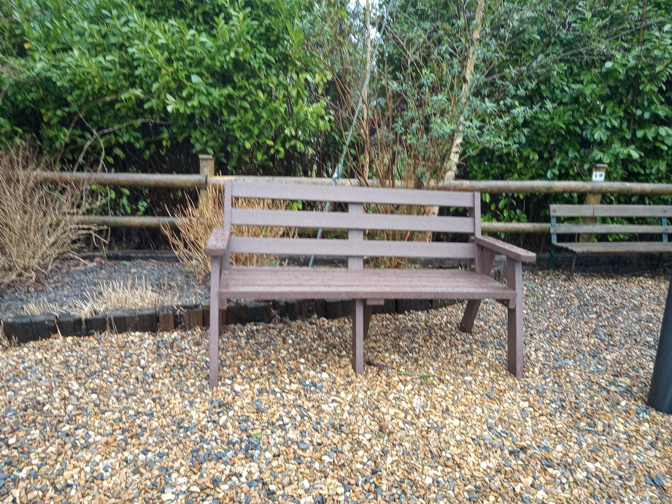
The Council also provides the public toilet facility in Llanddowror village, next to the Meeting Room. This is generally open from Easter until the end of October, and is well used by local people and also those passing through the village for work as well as tourists. One significant change in 2021-22 was that the Council decided to employ a contractor to carry out the toilet cleaning, rather than relying on local volunteers. They are really grateful to those volunteers who took on the cleaning of the toilets for so long – we really do thank you for doing that unsung task so reliably and efficiently for so long.


Looking forward
We want to continue helping our communities providing physical resources such as seating and waste bins to improve the area, so you may well see more appearing over the coming years.
We also this year are making the Meeting Room available free of charge for local individuals or groups who may wish to use it throughout the summer and autumn of 2022. We know that there is still concern about meeting people or gathering together, after the last two pretty stressful years, and we want to do our bit to encourage people to feel able to meet together in what is a safe space in the heart of Llanddowror.
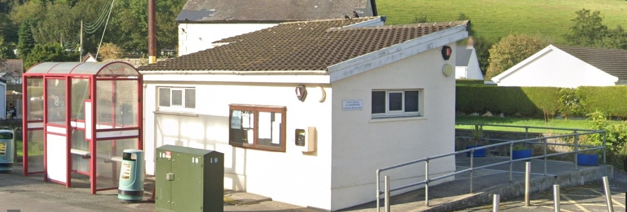
If anyone is interested, please do get in touch with any of the Councillors, or with the Clerk – contact details below.
Looking further ahead, we also are hoping to provide some new play equipment for both communities in the coming years – it may only be one piece at a time, but we recognise the importance of play and know that a good play area, such as in Llanddowror Pocket Park or in the LCDA grounds, are of real benefit to our communities. So, watch this space – well, those spaces!

Contact details
Your Councillors are:
David Howells – North Ward
Phill Pickersgill – North Ward
Eric Haines – North Ward
Nigel Hodson – North Ward
Terence Langdon – South Ward (Vice Chairman)
Sandra Hewens – South Ward (Chairman)
Gwyn Owen – South Ward

Jane Tremlett covers this area as part of her remit as County Councillor.
Vicky Mitchell is the Clerk/RFO – clerkllcc@gmail.com

Our website is llanddowror-llanmiloe.wales On it you can find out more about the history of our area, what is happening now, and also the work of the Council. Any queries, just get in touch.

