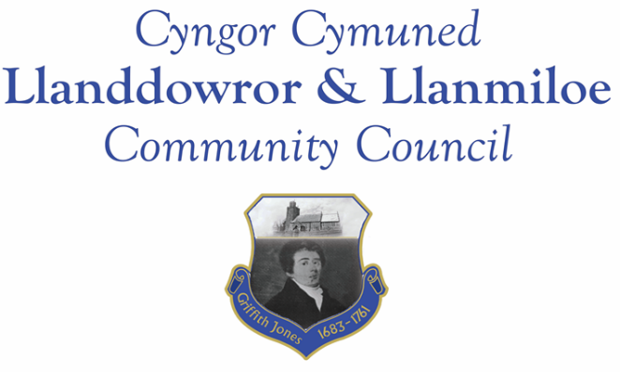

NOTICE OF MEETING

To All Members of Llanddowror & Llanmiloe Community Council.
I hereby summon you to attend the meeting of the Council, starting at 7.00pm on Monday 13th March 2023, for the transaction of the business outlined in the agenda below.
This meeting will be held in Llanddowror Meeting Room unless Zoom access is requested.

Vicky Mitchell – Clerk

Agenda

1. Apologies for absence.

2. Declaration of personal and prejudicial interests.

3. Questions from members of the public regarding items on the agenda.

4. Adoption of previous minutes of meeting held on 13th February 2023.

5. County Councillor’s report, including on matters raised in previous meetings, specifically:
Sandbag containers and bag provision; update on Llanddowror enforcement issue.

6. Clerk’s report.

7. Matters ongoing from previous minutes requiring discussions or decisions, not covered above:
- Community projects – receive any new information on specific projects – outstanding agreed one was: working with both community associations to provide play equipment in both communities. Request from LCDA for the match funding to cover costs – project started.
- Llanddowror Old Café site – consider any recent information received on planning application or enforcement process and agree any next steps to take that are available to this Council.
- Receive any feedback on Llanddowror Meeting Room donations box.
- Consider provision of donation to Llanmiloe School PTA to assist with costs of goalposts and bike racks.

8. New business.

- Consider replacement of bollards at Meeting Room to allow/improve parking by public service vehicles and Meeting Room users. See report provided.
- Consider renewal of One Voice Wales membership – email 23-2-23
- Note IRPW report for 2023-24. Consider policy as regards the office consumables for Cllrs. Consider whether to update policy as regards the optional allowances.
- Hedge removal in Llanddowror – possible planning breach.

9. Financial Report
- Current financial situation: Financial report appended to agenda.
- Income received: None since last meeting.
- Invoices to pay:
- Clerk monthly salary and expenses – March.
- HMRC monthly payments – March.
- Dwr Cymru - £20.50 (direct debit) per month.
- BLC – toilet cleaning March - £80.00
- One Voice Wales - £148.00 (if membership to be renewed)
- ?? LCDA - £3500.00 – providing match funding for play ground rejuvenation.

10. Significant correspondence.
- One Voice Wales training opportunities.

Any other correspondence received prior to meeting but after the date of publication of this agenda will be brought to the attention of the meeting for consideration.

11. Planning matters.

PL/05469 - Erection of ground maintenance & machinery storage shed (in retrospect) - Land East of Llanmiloe House, Llanmiloe, Laugharne, SA33 4TZ.Application registered 22-02-2023.

PL/05154 - Retrospective change of use of a cafe car park to an enclosed yard to house rescue dogs including the retention of storage containers and a 2.1m high security fence. Dan y Pound Cottage, Llanddowror. SA33 4HJ. Application registered 14/12/2022. Decision – full refusal – 17-2-23.

Any planning received prior to meeting but after the date of publication of this agenda will be brought to the attention of the meeting for consideration.

12. Councillors’ reports for information or items for next meeting.

13. Date of next meeting – 17th April 2023. Note date change as previous agreed.

Meeting dates for 2023:

March 13th 2023 April 17th 2023
May 15th 2023 12th June 2023
11th September 2023 9th October 2023
13th November 2023 11th December 2023
Meetings to be either in Llanmiloe Resource Centre, with hybrid access via Zoom provided as required, or in Llanddowror Meeting Room, or fully via Zoom.

