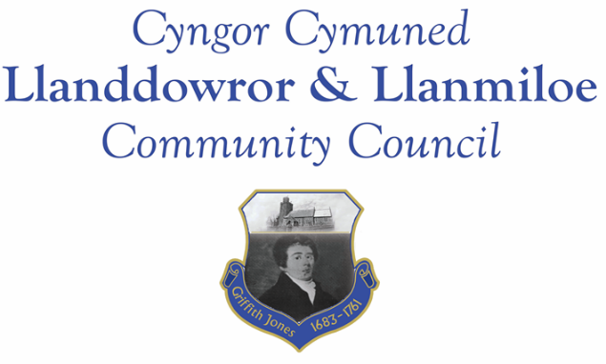
Llanddowror and Llanmiloe Community Council – Data Breach Policy

Llandowror and Llanmiloe Community Council recognises that it is essential to ensure that all personal data that is held by it is held securely. It also recognises that as a Data Controller it is responsible for the processing of data, and that it should ensure that the purposes and means of that processing are legal. This policy is to state how it will manage the process should there be a data breach of information that is held by it.

- The Council has adopted the model data breach reporting form from SLCC.

- Should the Clerk become aware of a data breach, she will follow the steps on that form. Once completed the form will be retained by the Clerk.

- Any data breach will be reported in the first instance to the Council’s Clerk. The Clerk will decide if the breach is likely to be a risk to an individual’s rights and freedoms. This decision and the reasons will be documented.

- If there is unlikely to be a risk, then the breach will be managed by the Clerk. If there is likely to be a risk, then the breach will be reported to the ICO within 72 hours of becoming aware of it.

- In all cases the breach will be reported to the next Council meeting, in private session. It will be up to the Council, as Data Controller, to review procedures in order to ensure that they prevent any further such breach as far as possible.

Adopted September 2018

