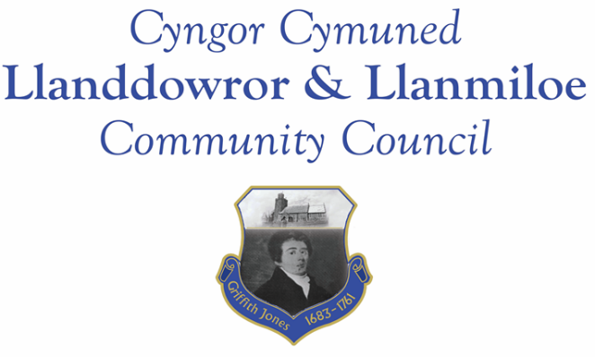

NOTICE OF MEETING

To All Members of Llanddowror & Llanmiloe Community Council.
I hereby summon you to attend the meeting of the Council, starting at 7.00pm on Monday 12th December 2022, for the transaction of the business outlined in the agenda below.
This meeting will be held in Llanmiloe Resource Centre, unless Zoom access is requested.

Vicky Mitchell – Clerk

Agenda

1. Apologies for absence.

2. Declaration of personal and prejudicial interests.

3. Questions from members of the public regarding items on the agenda.

4. Adoption of previous minutes of meeting held on 14th November 2022.

5. County Councillor’s report, including on matters raised in previous meetings, specifically:
Sandbag containers and bag provision; site meeting for Llanddowror enforcement issue.

6. Clerk’s report.

7. Matters ongoing from previous minutes requiring discussions or decisions, not covered above:
- Community projects – receive any new information on specific projects – those agreed were: working with both community associations to provide play equipment in both communities, Llanddowror Pocket Park tree management.
- Llanddowror Old Café site – consider any recent information received on enforcement process and agree next steps to take that are available to this Council.
- Receive any feedback on Llanddowror Meeting Room donations box.

8. New business.

- Consider and agree budget for 2023-24 financial year.
- Consider and agree precept amount to request for 2023-24 financial year.

9. Financial Report
- Current financial situation: Financial report appended to agenda.
- Income received:.
- Invoices to pay:
- Clerk monthly salary and expenses – December.
- BLC – toilet cleaning December - £tbc
- HMRC monthly payments – December.
- CCC – Llanddowror replacement seating bench - £1074.00
- Clerk re-imbursement for laptop and software purchase as previously agreed - £461.98
- Dwr Cymru - £20.50 (direct debit) per month.

10. Significant correspondence.
- One Voice Wales training opportunities.

Any other correspondence received prior to meeting but after the date of publication of this agenda will be brought to the attention of the meeting for consideration.

11. Planning matters.

Any planning received prior to meeting but after the date of publication of this agenda will be brought to the attention of the meeting for consideration.

12. Councillors’ reports for information or items for next meeting.

13. Date of next meeting – 9th January 2023.

~~~~~~~~~~~~~~~~~~~~~~~~~~~~~~~~~~~~~~~~~~~~~~~~~~~~~~~~~~~~~~~~~~~~~~~~~~

Meeting dates for 2022-23:

December 12th 2022
January 9th 2023
February 13th 2023
March 13th 2023
April 10th 2023
Meetings to be either in Llanmiloe Resource Centre, with hybrid access via Zoom provided as required, or in Llanddowror Meeting Room, or via fully Zoom.

