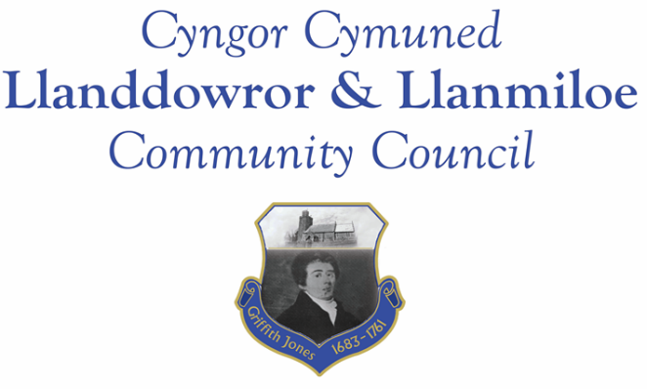

NOTICE OF MEETING

To All Members of Llanddowror & Llanmiloe Community Council.
I hereby summon you to attend a meeting of the Council, to be held by Zoom from 7.00pm on Monday 10th January 2022, for the transaction of the business outlined in the agenda below.

Vicky Mitchell – Clerk

1. Apologies for absence.

2. Declaration of personal and prejudical interests.

3. Adoption of previous minutes – 13th December 2021.

4. County Councillor’s report, including on matters raised in previous meetings:

5. Matters ongoing from previous minutes.
- Meeting Room door/water channel update.
- Llanmiloe School – Additional Community Governor.
- Flooding issues in Llanmiloe – email received from CCC Environment Dept.
- Agricultural Land Tribunal – Clerk report – consider whether to take actions as outlined in the report.

6. New business.
- Donation requests received. Consider any other donations the Council wishes to make this financial year.

7. Financial Report
- Current financial situation. Financial report appended to agenda.
- Income received -
- Invoices to pay – Clerk monthly salary and expenses – January.
HMRC monthly payments – January.
Dwr Cymru - £16.50 (direct debit) per month

8. Significant correspondence.
- One Voice Wales training opportunities.

Any other correspondence received prior to meeting but after the date of publication of this agenda will be brought to the attention of the meeting for consideration.

9. Planning matters.

Any planning received prior to meeting but after the date of publication of this agenda will be brought to the attention of the meeting for consideration.

10. Councillors’ reports or items for next meeting.

11. Date of next meeting – 14th February 2022.

