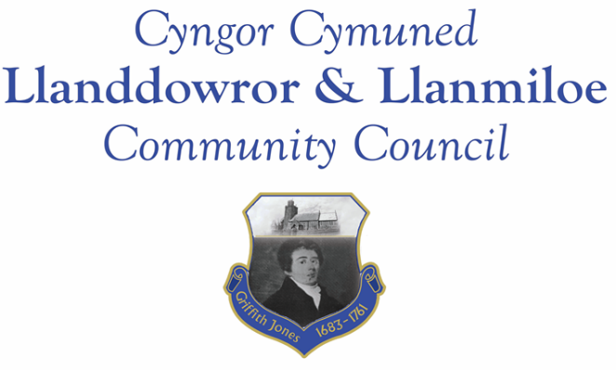

Minutes of the normal meeting of Llanddowror and Llanmiloe Community Council
Held Monday 12th June 2023.

Present Cllrs Eric Haines (meeting Chairman), David Howells, Sandra Hewens, Terence Langdon, Nigel Hodson.
- Apologies. These were received from Phill Pickersgill, Leigh Clarkson, Gwyn Owen and County Councillor Jane Tremlett, and accepted..
- Declarations of personal interests. No interests were declared.
- Questions from members of the public regarding agenda items. There were no members of the public present.
- Adoption of previous minutes for the normal meeting and the annual meeting on 15th May 2023. These were agreed by all, and duly signed by the Chairman.
- County Councillor’s report: County Cllr Tremlett had provided an emailed report, which was read out to the meeting. Grit bins could not be provided by the Meeting Room because it was no longer CCC’s responsibility. The Clerk was asked to re-iterate the need for sandbags and the removal of the rusted container near Pocket Park and the need for a new one to be placed centrally.
- Clerk’s report. The Clerk had previously circulated the report and provided verbal updates on the various matters. She would chase up on ongoing matters and provide updates by email through the summer to all.
- Matters ongoing from previous minutes:
- Progress report on Meeting Room redecoration. This had not yet started, but would soon. It was agreed to add the additional sum of £300 for remedial plastering to the contract.
- New business:
- Llanddowror Meeting Room. It was agreed to purchase and fit a keysafe to provide better access to the building. It was also agreed that the North Ward Councillors would review the current contents and removal and disposal of unwanted items. The Clerk was authorised to negotiate new electricity contract for when the current one expired.
- Annual Report 2022-23. A draft copy had been previously circulated. All were pleased with it, and happy to adopt it for the year. The Clerk would publish it on the website.
- External audit for 2021-22. The audit report for that year had been received after the publication of the agenda. The Council was very pleased to note that they had received an unqualified audit, with no matters of concern raised at all.
9. Financial Report
The current financial situation was provided to all Cllrs.
- Income received: £0.00
- Invoices to pay:
- Clerk monthly salary and expenses – June. The Council also noted in advance to the contractual payments for July and August.
- BLC – toilet cleaning June - £64.00. The Council also noted in advance to the contractual payments for July and August.
- HMRC monthly payments – June. The Council also noted in advance to the contractual payments for July and August.
- Dwr Cymru - £50.00 (direct debit) for June. The Council noted in advance the same payment would be taken in July and August.
- Amazon – Mastersafe keylock - £15.98
- ICO annual registration - £35.00

10. Significant correspondence.
- One Voice Wales training opportunities. These were noted.
- Thank you letter from Llanmiloe School PTFA for the donation towards swimming lesson transport. This was noted.
- Armed Forces day event in St Clears 25th June. This was noted, and Cllr Howells agreed to represent the Council.

11. Planning matters.
.
SCO/06007. Screening opinion. Environmental Impact Assessment (EIA) screening opinion to determine if an EIA is required for the proposed development to install solar panels. MoD, Pendine. Received 26-5-2023. There were no objections and it was agreed an EIA screening would be worthwhile.

PL/06033 Variation of Condition 1 on W/28331 (Inert landfill, where inert material will be used to raise the level of the site before being returned to agricultural use) - Talfan Farm, St Clears, Carmarthen, SA33 4HJ Received 23-5-2023. There were no objections.

12. Councillors’ reports for information or items for next meeting.
It was agreed that an extra meeting would be called by the Clerk if required for plannng or other matters during the summer.

Cllr Howells stated that a local resident had been ensuring the boundary stones of the area remained safe and visible for the last 29 years. It was agreed that this merited recognition.

Cllr Hewens stated Bro Myrddin had carried out an inspection of their propoerties recently.

Cllr Haines expressed his praise (which was echoed by the other Councillors) for the excellent organisation and effort put into the recent ‘Climbing Everest’ event at MorfaBay to raise money for their teacher who is ill.

13. Date of next meeting – 11th September 2023.
There being no further business the meeting concluded at 8.56pm

