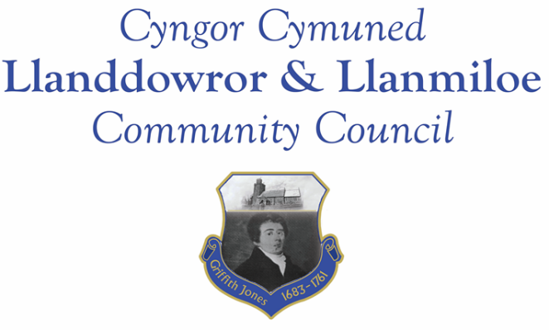

Minutes of the normal meeting of Llanddowror and Llanmiloe Community Council
Held in Llanmiloe Resource Centre and via Zoom, Monday 9th May 2022.

Present Cllrs, Sandra Hewens (Chairman), Gwyn Owen, David Howells. Terence Langdon.
- Apologies. There were apologies received from Eric Haines and Phill Pickersgill
- Declarations of personal interests. No interests were declared.
- Questions from members of the public regarding agenda items. The Clerk had previously circulated a report outlining the new legislative requirements for this and two other measures to be taken by the Council. The ground rules for this item going forward were discussed and agreed.
- Adoption of previous minutes for the meeting on 11th April 2022. These were agreed, and duly signed by the Chairman.
- County Councillor’s report: County Cllr Tremlett did not attend the meeting and had not provided a report to update the Council. Cllr Tremlett had said in the February meeting that she would provide more information on a number of items such as speed signage near the school and in Llanmiloe village itself; speed warning signs for Llanddowror; highways and environmental issues around New Mill. The Clerk would follow up on these issues.
- Clerk’s report. The Clerk had previously circulated the report with any relevant updates. One new item had been raised - an event held locally – but that had passed off without incident.
- Matters ongoing from previous minutes:
- Agricultural Land Tribunal. There was no update to provide – a contact with NRW would be forthcoming as soon as possible.
- New business:
Community projects:
- Llanmiloe pill clearance – the Clerk would aim to get indicative prices and further information on this. It was agreed that it would be highly beneficial, but would need be done at the correct time of year (considering vole population etc.), could only be done with proper safety precautions, and without any future commitment for the Council. The Council’s ongoing concerns on this would be raised with the local MP and AM.
- Llanddowror seating; The Clerk would review the seating in the village and research potential replacement or repair options, and report back.
- Play equipment for both communities – A report from the Clerk with some priced elements had been previously circulated. It was stated that any purchases would be from precept monies, not from external funding, so it might only be one item that could be bought every couple of years. The information would be taken to both LVA and LCDA to inform discussions.
- Election expense forms. The Clerk outlined the legal requirement for the completion of these. They were completed by those present, and would be sent off in due course.
- Donation suggestion in memoriam for recent passing of an individual. This was discussed and since it is not possible to donate to the school directly, it was agreed to donate £300.00 from the Chairman’s fund to Llanmiloe School PTFA to support their work with the school.
- Jubilee memorabilia. The Clerk had provided information on potential mugs for schoolchildren, and also jubilee coins. After discussion it was agreed to purchase and donate jubilee coins to them. The Clerk would organise the purchase of these.
- Llanddowror toilets. It was agreed to re-open these from now until approximately the end of October. The previous contractor had provided an updated quote, and the Clerk had obtained a comparative quote from a local contractor. After discussion it was agreed to go with the local contractor, on a six month probationary period. The Clerk would make the arrangements, including purchasing consumables as necessary.
- Financial report:
An up to date report on the finances of the Council had been previously circulated, and was discussed. The receipt of the first part of the precept - £4166.66, was noted. It was also noted that the lack of actual elections meant the Council missed out on any income from use of the Meeting Room by CCC staff.

The following invoices were noted, and agreed for payment by all:
- Clerk monthly salary and expenses - May.
- Clerk monthly tax due – May.
- Dwr Cymru direct debit £16.50 monthly – this would be increasing to £20.50 monthly from the start of June, it was noted.
- Llewelyn Davies - internal audit work for financial year 2020-21 - £300.00
- ICO – payment for membership due at the start of June - £35.00
- Donation mentioned above to Llanmiloe School PTFA - £300.00
The Clerk would enquire about the invoice for payment for use of the Resource Centre.

- Significant correspondence
- One Voice Wales training opportunities. These were noted.
- Carmamarthenshire YTFC Rally invitation. This was noted.

- Planning matters:
There were no planning applications that had been received since the last meeting.

- Councillors’ reports of issues and items for next meeting.
Residents in Llanddowror had asked whether the streetlights in the village could be turned off at night. The Clerk would make enquiries and bring back the response to the next meeting.
Concerns were raised regarding the road edges of the road between New Mill and Three Lords. It was reported that the drop off was dangerously deep, and was causing damage to vehicles who moved out of the road centre to pass each other. The Clerk would report this safety issue to CCC.
Concerns were raised about vehicles parking almost permanently in the passing bay on the Bro Myrddin estate in Llanmiloe. The Clerk would bring this to the attention of Bro Myrddin.
Finally it was stated that there would be Jubilee events in Llanddowror on Friday 3rd and in Llanmiloe on Saturday 4th – all were welcome.
- Date and venue of next meeting
The next meeting was planned for June 13th 2022. It was agreed to plan to have this in person in Llanmiloe Resource Centre with remote access enabled for those who wished it.
There being no further business the meeting concluded at 9.00pm.

