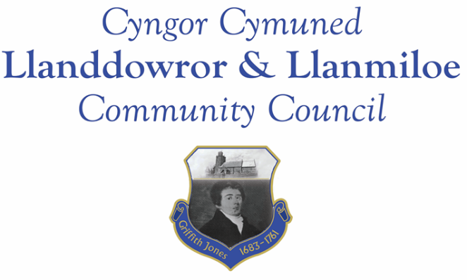
Minutes of the normal meeting of Llanddowror and Llanmiloe Community Council
Held in the various locations via Zoom, Monday 11th January 2021.

Present Cllrs Terence Langdon, Gwyn Owen, Sandra Hewens, Nigel Hodson, David Howells, Phill Pickersgill and County Cllr Jane Tremlett, plus a member of the public.
Apologies. These were received from Cllr Chris Holt.
Declarations of personal interests. Cllr Hewens declared a personal interest in the flooding in Wood End.
Adoption of previous minutes. The minutes of the meeting of 14th December 2020 had been previously circulated. The minutes were accepted as a true record and would be duly signed at the earliest opportunity – proposed Cllr Howells, seconded Cllr Langdon and agreed by all.
County Cllr’s report. Cllr Jane Tremlett went through the various issues that had been raised in detail, and they were discussed in turn. An underlying issue causing delays to several of them was the current lockdown, which prevented officers going out to investigate locations in person.
Bottle bank trial. When the bottle bank had been removed from Llanddowror alternative sites in the locality had been assessed to see if they could be an alternative. CCC officers would look at the proposed site and do a risk assessment as soon as possible.
Llanddowror traffic speed reduction. Cllr Tremlett had been informed that reducing to 20mph might be seen as dropping the speed to an artificially low level, so there could be reluctance to do this. Any change would require a traffic regulation order. The provision of a yellow matrix speed warning box would be considered by officers and be considered by GoSafe – subject to a site visit, currently delayed for covid-19 lockdown. The speed limit working group (including police membership) would review the data gathered two years ago. It was stated that the delay was frustrating for residents, and Cllr Tremlett suggested having a site visit to walk and see the issues with GoSafe and CCC officers once restrictions permitted to discuss what could be done.
Llanmiloe road surface deterioration. Urgent remedial work has been requested for the majority of this stretch, and it was under regular inspection from officers (lockdown permitting).
Llanmiloe speeding – suggested road bump warning signs. This would be assessed once officers could do a site visit. Cllr Tremlett had passed on information about the accident last year involving three cars in the school / Qinetiq area – it was confirmed that police had attended the scene.
Flooding in Llanmiloe. NRW annually cleaned the pills for which they were responsible, the remainder were the responsibility of landowners, not CCC. Some of the land sold to the WDA for the Wales Coastal Path was them leased to the LCDA, so they were responsible for that stretch. Cllr Tremlett stated that CCC were not responsible for any pill clearance. It was agreed to request a map from NRW showing their responsibility, and work from there on establishing ownership and maintenance responsibility.
The CCC planning enforcement officer was in contact with one resident particularly affected by flooding and sewage ingress, and would contact others, one of whom has lived in the area for decades without this issue occurring before. The officer would investigate if there was any evidence of watercourse diversion impacting residents or roads in the area. It was stated that one resident had three tankers coming daily to pump out water to protect the property. It was stated that sewage issues for one particular area were being raised from 2009 onwards by this Council.
Cllr Tremlett also stated that CCC can and do contact landowners over reports of mud on the roads, or potential slurry issues, but if they are significant then reporting to the police is helpful because they have more powers of enforcement.
Matters ongoing from previous minutes:
- Llanddowror speed limit. This had been discussed above.
- Meeting Room water channel. The contractor had been contacted several times over the preceding month - the Clerk would continue to chase to get the work done.
- Councillor vacancies. One individual had expressed interest, and was in attendance at the meeting. It was agreed by all that they would be welcome as a Councillor, and so the Council welcomed Catrin Davies onto the Council.
- Llanddowror bottle bank trial. This had been discussed earlier in the meeting.
- Community activities by the Council. The Clerk reported that the seats for Llanmiloe and District Community Association playing field had been delivered and were very much appreciated.
New business:
- Flooding and associated issues in Llanmiloe. The Clerk had sent a letter to various relevant organisations seeking information and assistance. A summary report of feedback had been provided to the Council prior to the meeting. This had been included within the discussion above.
Financial report:
An up to date report on the finances of the Council had been previously circulated, and was accepted as accurate.
The following invoices were noted, and agreed for payment – proposed by Cllr Howells, seconded by Cllr Hewens and agreed by all:
- Clerk monthly salary and expenses.
- Clerk monthly tax payment.
- Dwr Cymru direct debit £13.50 monthly.
- Danfo – toilet cleaning contract - £84.00 for December.
- Marmax - seats for Llanmiloe - £1130.40.
- WAO - external audit 2019-20 - £333.50.
The Clerk stated that the Council had budgeted for room hire of Llanmiloe Resource Centre, which had not been required since meetings were of necessity held remotely. It was agreed to donate this amount (£50.00) to the Resource Centre in view of their reduced income this financial year.
Correspondence
Items of correspondence since the last meeting had been forwarded upon receipt. Specific items to note were:
- One Voice Wales remote training opportunities in January
- Precept request from CCC – this had been submitted..
- Census Engagement Officer email regarding census on 21-3-2021.
Planning matters:
No planning matters had been received since the last meeting.

Councillors’ reports for next meeting.
Councillors reported that some streetlights were not working. The details would be passed to the Clerk for reporting. It was also reported that there was still a sodium streetlight in New Mill.
It was asked when the blue bags would be delivered – the Clerk would raise the query and report back.
Cllr Howells reported that the drains in Llanddowror had been cleared two days after the issue was raised last month – he expressed residents’ thanks for the swift response.
The Clerk reminded all that there was still some grant monies available for covid-19 related work in the community.
Date and venue of next meeting
The next meeting was planned for 8th February 2021, most probably via Zoom. The Clerk would call a meeting beforehand if it was required.
There being no further business the meeting concluded at 8.05pm.

