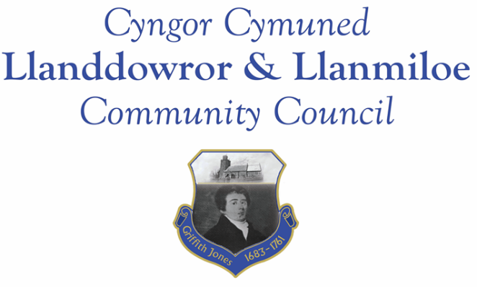
Minutes of the normal meeting of Llanddowror and Llanmiloe Community Council
Held in the various locations via Zoom, Monday 10th January 2022.

Present Cllrs David Howells (Chairman), Sandra Hewens, Terence Langdon, Gwyn Owen, Phill Pickersgill, Eric Haines, Nigel Hodson, County Cllr Jane Tremlett.
Cllr Howells started the meeting with a short statement of sadness regarding the number of individuals connected to the Council who had passed away in the last couple of years. He mentioned the sad losses of the husband and son of Cllr Tremlett; the former Clerk and former Cllr Frank Roberts; the former Cllr Tony Paradice; and now the passing of Cllr Chris Holt, serving Cllr and Vice-Chairman. He stated that each case was a heartfelt loss both for the individual family and for the community. The Council then held a minutes silence out of respect.
Apologies. There were no apologies received.
Declarations of personal interests. No interests were declared.
Adoption of previous minutes. The minutes of the meeting of 14th December had been previously circulated. The minutes were accepted as a true record, and so would be duly signed at the earliest opportunity.
County Cllr’s report. County Cllr Tremlett stated in relation to the list of ongoing issues that had been raised some months back that there had been some system and personnel changes within CCC, which included a re-organisation of the Planning department and also changes at the top levels of the Highways department. It was hoped that these would enable better management of issues henceforth.
It was reported that the two planning issues were still under investigation. Whether there had been any more recent water ingress issues would be investigated.
An issue was raised regarding the path opposite Llanmiloe old Social Club – this was dangerous with rotting slippery leaves and the streetlight was on permanently. Cllr Tremlett said she would report this accordingly.
Cllr Tremlett then left the meeting.
Matters ongoing from previous minutes:
- Meeting Room water channel and door. The door was on order – once it arrived the contractor would fit it and also do the water channel.
- Additional School Governor – Llanmiloe School. This was again discussed, and it was agreed to put forward Cllr David Howells for this role. The Clerk would do so.
- Flooding issues in Llanmiloe. The Clerk had previously circulated an email received from the Environment department of CCC, which was briefly discussed.
- Agricultural Land Tribunal. The Clerk had previously circulated a report updating Cllrs on the current situation. It was agreed to proceed as suggested by the CCC officer, with this Council co-ordinating a joint application to the ALT.

New business:
- Donation request. The Clerk informed the meeting of the request from Noah’s Ark (the Children’s Hospital charity based in Cardiff). It was agreed to focus donations locally if at all possible – Cllrs would consider this in the February meeting.
Financial report:
An up to date report on the finances of the Council had been previously circulated, and was discussed.
The following invoices were noted, and agreed for payment by all:
- Clerk monthly salary and expenses - January.
- Clerk monthly tax due – January.
- Redi Plastics Ltd - £774.62 – Meeting Room door.
- Broxap - £1469.76 (tbc) – 4 waste bins for Llanmiloe.
- Dwr Cymru direct debit £16.50 monthly
Significant correspondence
- One Voice Wales training opportunities.

Planning matters:
PL/03048. Amendments to a previously granted planning permission (PL/01632) for a double storey extension. Ty'r Felin, Llanddowror, Carmarthen, SA33 4HJ Application registered 17-11-2021. This had been granted on 10-1-2022.

Councillors’ reports of issues and items for next meeting.
The Clerk reported that the roadside warning bollards along the A4066 had been replaced. There was a delay to the replacement of the cats-eyes because current covid-19 safety measures of CCC meant two officers could not vehicle-share which was required to pinpoint the replacements needed. She also reported that the four waste bins for alongside the Llanmiloe playing field were on order with delivery expected in February.
The Clerk had raised with CCC the Council’s concerns about the A4066 sleeping policemen still not having been replaced after the last meeting, as well as the request for one near the school for safety purposes, and a request for a meeting regarding the speed awareness signs coming into Llanddowror, but had had no response. These would be raised again.
The antisocial behaviour in Llanmiloe appeared to have reduced. Information on how to report any incidents was widely available and the PCSOs were maintaining regular contact with the Clerk.
The Clerk would pass on the ‘no dog fouling’ stickers she had obtained from CCC.
Concerns were raised about fresh soil appearing on the mound at the end of the bay opposite the MoD site. The Clerk would query this and whether it was flytipping with CCC.
Concerns were raised about a tree in Llanddowror, and a branch that had fallen from it into Llanddowror Brook. The tree was the responsibility of the landowner but the Clerk would report the branch to CCC for removal. Another tree on the back road in Llanddowror was raised as an issue - this also would be reported to CCC.
Concerns were raised about the streetlight opposite the Social Club still on 24/7, and the state of the footpath beneath. This would be reported to CCC.
It was agreed that the Council wished to mark the contribution of Chris Holt to the Council and community – his family would be asked whether they would approve of a plaque being placed on a community bench to commemorate him.
Date and venue of next meeting
The next meeting was planned for February 14th 2022, most probably via Zoom.
There being no further business the meeting concluded at 8.15pm.

