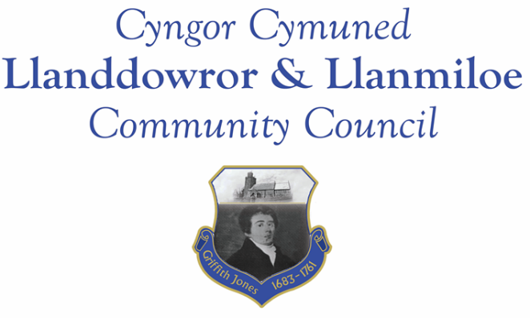

NOTICE OF MEETING

To All Members of Llanddowror & Llanmiloe Community Council.
I hereby summon you to attend a meeting of the Council, to be held as a hybrid meeting starting at 7.00pm on Monday 11th April 2022, for the transaction of the business outlined in the agenda below.

Vicky Mitchell – Clerk

1. Apologies for absence.

2. Declaration of personal interests.

3. Adoption of previous minutes – 14th March 2022.

4. County Councillor’s report, including on matters raised in previous meetings, specifically:
- Speed management issues: Llanddowror warning signs request; Llanmiloe speed bumps near school; Llanmiloe signage in village inadequate especially at night.
- Highways issues around New Mill from heavy vehicle use.

5. Clerk’s report.

6. Matters ongoing from previous minutes requiring discussions or decisions:
- Agricultural Tribunal / NRW approach – receive any update and consider any further related actions.

7. New business.
- Receive the Audit Wales report on for 2020-21. Consider this and what actions might therefore be taken by this Council as a result.

8. Financial Report
- Current financial situation. Financial report appended to agenda.
- Income received -
- Invoices to pay – Clerk monthly salary and expenses – April.
HMRC monthly payments – April.
Dwr Cymru - £16.50 (direct debit) per month
CCC – streetlight replacement repayment - £1251.00
CCC – streetlight maintenance and energy for 2021-22 - £1969.67

For information: streetlight charges 2018-19 were £3680.07; 2019-20 - £2963.09; 2020-21 - £2764.23. Energy prices increased in last year.

9. Significant correspondence.
- One Voice Wales training opportunities.

Any other correspondence received prior to meeting but after the date of publication of this agenda will be brought to the attention of the meeting for consideration.

10. Planning matters.

PL/03673. Non material amendment to PL/00810 (Re-sizing and repositioning the fenestration with the addition of more glazing to the rear of the the extension). Halldown Farm, Cross Inn, Carmarthen, SA33 4QS. Registered 15-3-22. Application granted 22-3-22.

Any planning received prior to meeting but after the date of publication of this agenda will be brought to the attention of the meeting for consideration.

11. Councillors’ reports or items for next meeting.

12. Date of next meeting – 9th May 2022. This to be the annual meeting, followed immediately by the normal monthly meeting.

~~~~~~~~~~~~~~~~~~~~~~~~~~~~~~~~~~~~~~~~~~~~~~~~~~~~~~~~~~~~~~~~~~~~~~~~~~

