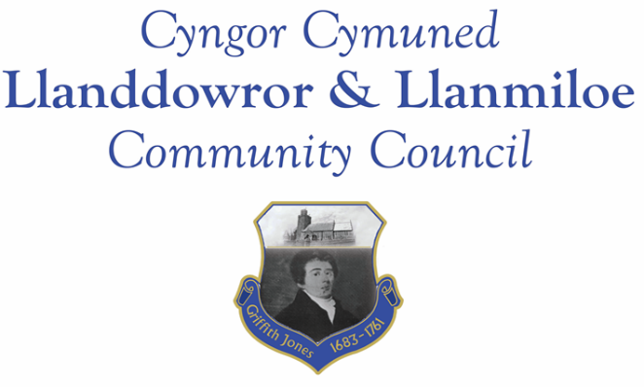

NOTICE OF MEETING

To All Members of Llanddowror & Llanmiloe Community Council.
I hereby summon you to attend two meetings of the Council, to be held at various locations from 7.00pm on Monday 10th May 2021, for the transaction of the business outlined in the agendas below.

Vicky Mitchell – Clerk

Annual meeting agenda

1. Apologies for absence

2. Declaration of personal interests.

3. Address by outgoing Chair.

4. Election and installation of new Chair then Vice-Chair for 2021-22. Signing of declarations of office to be done onscreen and shown to all.

5. Review of annual accounts for 2020-21. Receive report of the Internal Auditor. Review the governance statementsi n the Annual Return – Chairman to sign these as soon as possible if they are agreed by Council.

5. Review and re-adoption of Code of Conduct, Standing Orders, Financial Regulations, Financial Risk Assessment and the other Policies that have been previously agreed by the Council: Welsh, Complaints, Reserves, Equal Opportunities, Dignity, Bullying and Harassment, Election and Co-option.

6. Review and consider adoption of publication scheme for Council.

7. Review and agree dates for normal Council meetings for the coming year. Meetings to be held using Zoom, to be reviewed once restrictions on public meetings are relaxed.

~~~~~~~~~~~~~~~~~~~~~~~~~~~~~~~~~~~~~~~~~~~~~~~~~~~~~~~~~~~~~~~~

Normal meeting agenda

1. Apologies for absence.

2. Declaration of personal interests.

3. Adoption of previous minutes – 12th April 2021.

4. County Councillor’s report. Some matters may overlap with those listed below.

5. Matters ongoing from previous minutes.
- Meeting Room water channel.
- Councillor vacancies.
- Flooding issues in Llanmiloe – to receive any updates.

6. New business.
- Litter pickers – proposal to purchase – see Clerk report
- Meeting Room door – needs repair.
- Letter from Pendine Community Council re parking.

7. Financial Report
- Current financial situation..
- Invoices to pay – Clerk monthly salary and expenses.
HMRC monthly payments.
Covid-19 support (CAVS grant £164.10
Dwr Cymru - £13.50 (direct debit)
Swalec – £37.33 (direct debit)
Danfo - £84.00 – toilet cleaning April
ICO – annual fee - £35.00

8. Significant correspondence.
- One Voice Wales training opportunities.

Any other correspondence received prior to meeting but after the date of publication of this agenda will be brought to the attention of the meeting for consideration.

9. Planning matters.

Any received prior to meeting but after the date of publication of this agenda will be brought to the attention of the meeting for consideration.

10. Councillors’ reports or items for next meeting.

11. Date of next meeting – 14th June 2021.

