Annual Report for Llanddowror and Llanmiloe Community Council 2022-23
Background
Llanddowror and Llanmiloe Community Council is the tier of local government that is closest to the communities and people that it serves, and it is focussed specifically on the interests and concerns of the people who live or work in Llanddowror, Llanmiloe and the various farms, businesses and within the area that it covers.
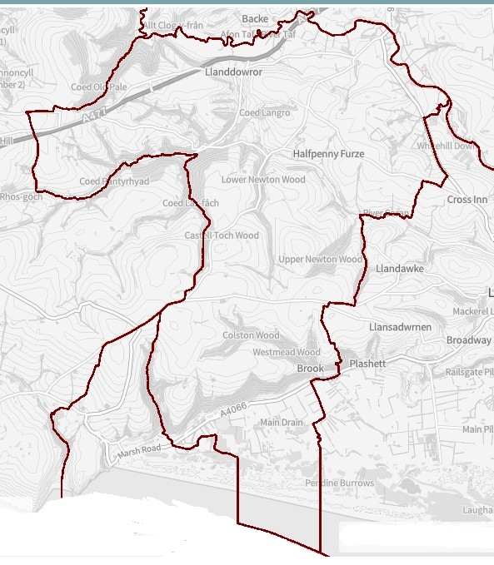
The Council is composed of ten Councillors, five from the South Ward focussed on Llanmiloe and five from the North Ward focussed on Llanddowror. These are elected to that position every five years by people in those wards. The Council works closely with the two thriving village associations that are very active in their communities. The Council has one part-time employee, the Clerk / Responsible Financial Officer.
In Llanddowror itself Llanddowror and Llanmiloe Community Council owns and runs the Meeting Room, and also the public toilets that are adjacent to it. In Llanmiloe the Llanmiloe and District Community Association own and run the Resource Centre, as well as the adjacent playing field.
Priorities
Our priorities are to support the people we serve and to enhance the area in which they live and work. To do this we work with other bodies such as Carmarthenshire County Council, Carmarthenshire Association of Voluntary Services, Bro Myrddin Housing Association, Qinetiq, Natural Resources Wales, Llanmiloe and District Community Association, Llanddowror Village Association, for instance.
The Council has neither the resources nor the legal ability to cover or manage everything that it is asked to do, and as the local Council we are sometimes expected to deal with things which are actually the responsibility of another body. We do our best though! Examples include fixing broken streetlights, sorting out potholes or road damage, or dealing with fly-tipping. When this happens, the request is passed on to the relevant body, and we will let you know.
We are always open to new ideas of how we can support and help you, and assure you we will do what we can, so please do get in touch via the Clerk – contact details at the end.
Activities and Achievements
Over the last year we have continued to work closely with the two village community associations. This led to this Council supporting both of them in their bids to the Wind Farm fund for play equipment, and providing march funding to really boost what could be provided in each community. We look forward to seeing the new play equipment in place. We have also supported both the Jubilee celebrations last year and the upcoming Coronation activities – providing donations towards the costs of the events and also providing special commemorative coins for all the Llanmiloe schoolchildren.
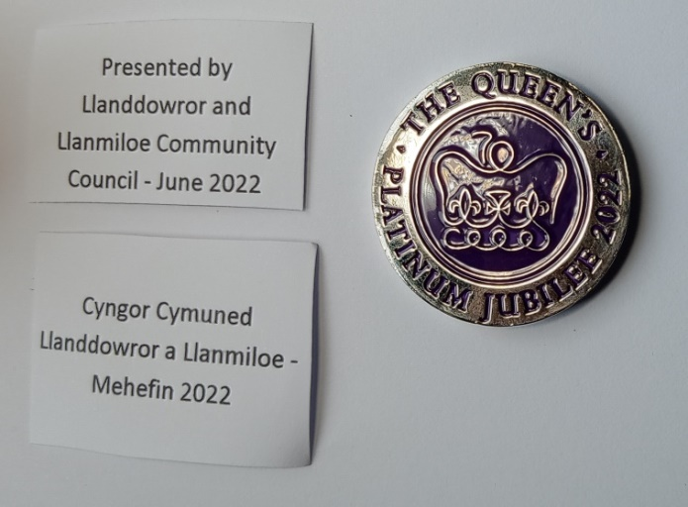
The public toilets in Llanddowror are well used and appreciated we know by both visitors and locals. We have therefore decided to keep them open all the year around.
We also during this year made the Meeting Room available free of charge for local individuals or groups who may wish to use it throughout the summer and autumn of 2022, which was appreciated when the cost of living is very much on everyone’s minds. To help the parking problems in Llanddowror we have worked with Llanddowror Village Association to remove most of the bollards outside the building – so now there are two more parking spaces available for those using the toilets or Meeting Room.
We are also delighted that our persistent lobbying of Carmarthenshire County Council and GoSafe about the speeds of traffic going through Llanddowror has resulted in ‘a village gate’ being installed by Carmarthenshire to the north entrance of the village. We hope this will encourage drivers to slow down as they come into our community.

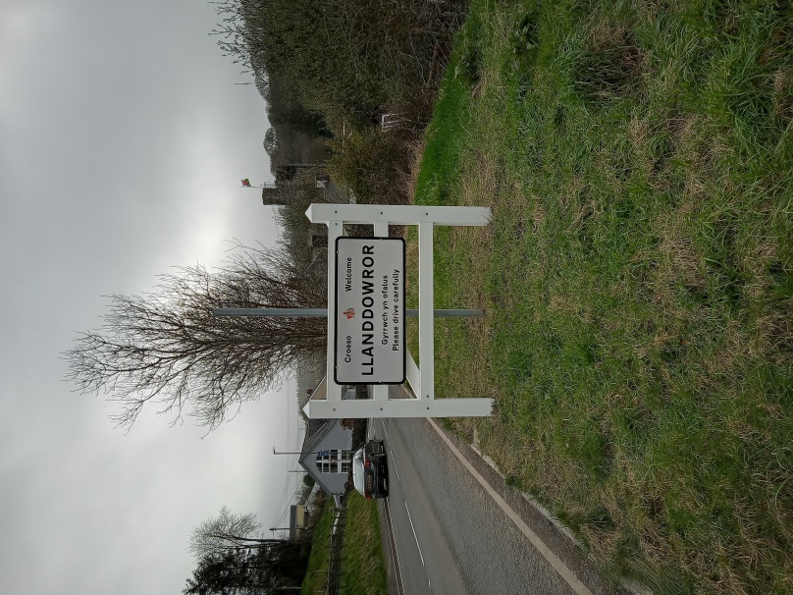

Biodiversity
The Council recognises the importance of improving the natural biodiversity of the area, indeed of the whole country, and works to positively support such initiatives. It is one of the factors considered when we consider our responses to local planning applications, and also any chemicals to be used by the Council, for example for maintaining the public toilets in Llanddowror. As a rural community we do encourage all local landowners to use bee-friendly agricultural habits as much as possible.
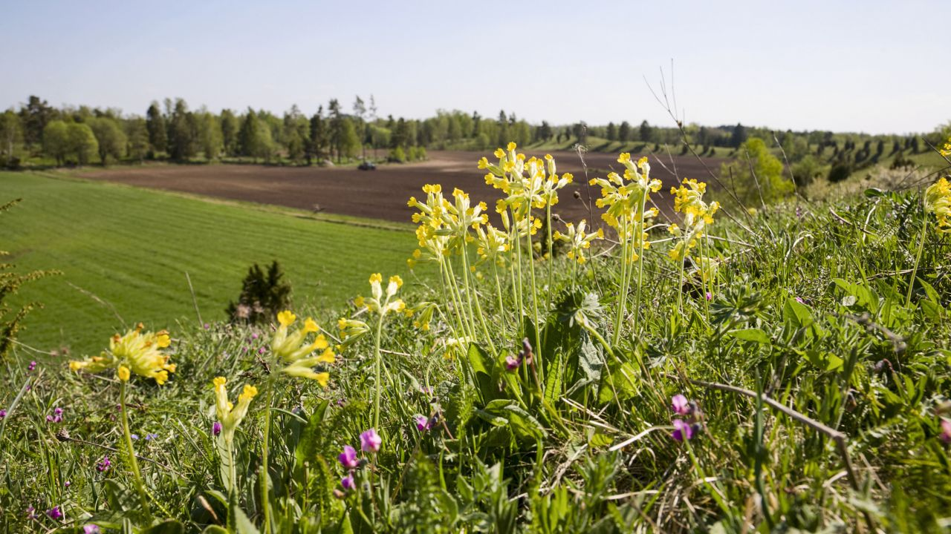
Looking forward
We want to continue helping our communities by providing physical resources such as seating and waste bins and also supporting events. Whether an individual or group, if you think we can help locally, please do get in touch.
This year should see the introduction of 20mph as the default speed through Llanddowror and on the side roads of Llanmiloe – we are currently lobbying for the whole stretch of the A4066 through the village to be reduced to 20mph for safety reasons.
If anyone is interested, please do get in touch with any of the Councillors, or with the Clerk – contact details below.
Contact details
Your Councillors are:
David Howells – North Ward Phill Pickersgill – North Ward
Eric Haines – North Ward (Chairman 23-24) Nigel Hodson – North Ward
Leigh Clarkson – North Ward Gwyn Owen – South Ward
Terence Langdon – South Ward (Vice Chairman 22-23, 23-24)
Sandra Hewens – South Ward (Chairman 22-23)
Jane Tremlett covers this area as part of her remit as County Councillor.
Vicky Mitchell is the Clerk/RFO – clerkllcc@gmail.com
Our website is llanddowror-llanmiloe.wales On it you can find out more about the history of our area, what is happening now, and also the work of the Council. Please do get in touch if you have any queries.

