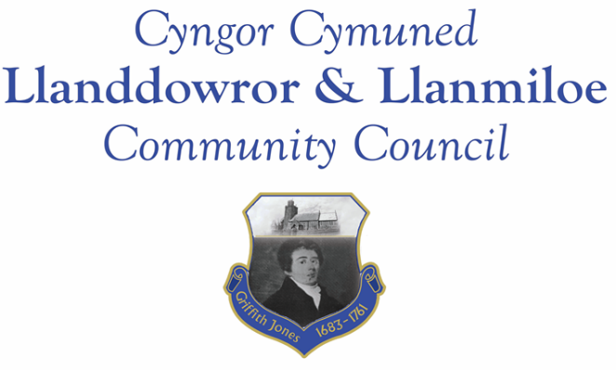

NOTICE OF MEETING

To All Members of Llanddowror & Llanmiloe Community Council.
I hereby summon you to attend the meeting of the Council, starting at 7.00pm on Thursday 18th August 2022, for the transaction of the business outlined in the agenda below. The meeting will be hed via Zoom.

Vicky Mitchell – Clerk

Agenda

1. Apologies for absence.

2. Declaration of personal and prejudicial interests.

3. Questions from members of the public regarding items on the agenda.

4. New business.
- Consider Llanmiloe pill drainage proposal and decide whether to proceed with the quote provided by a contractor and the CCC offer of assistance.

5. Date of next meeting – 12th September 2022.

~~~~~~~~~~~~~~~~~~~~~~~~~~~~~~~~~~~~~~~~~~~~~~~~~~~~~~~~~~~~~~~~~~~~~~~~~~

Meeting dates for 2022-23:

September 12th 2022
October 10th 2022
November 14th 2022
December 12th 2022
January 9th 2023
February 13th 2023
March 13th 2023
April 10th 2023
Normal meetings to be based in Llanmiloe Resource Centre, with hybrid access via Zoom provided as required.

