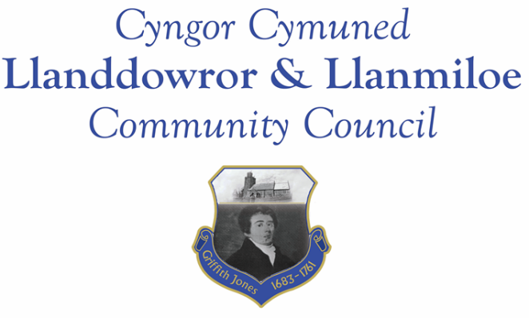

Minutes of the normal meeting of Llanddowror and Llanmiloe Community Council
Held Monday 17th April 2023.

Present Cllrs Sandra Hewens (meeting Chairman), Terence Langdon, Phill Pickersgill, David Howells, Leigh Clarkson, Eric Haines, Gwyn Owen, Nigel Hodson, plus 1 member of the public.
- Apologies. There were apologies received from County Cllr Jane Tremlett.
- Declarations of personal interests. No interests were declared.
- Questions from members of the public regarding agenda items. The two items queried (Llanddowror Meadows and Llanddowror Old Café) had updates provided in the main part of the meeting.
- Adoption of previous minutes for the normal meeting on 13th March 2023. These were agreed by all, and duly signed by the Chairman.
- County Councillor’s report: County Cllr Tremlett had given her apologies and no report was provided. The Clerk was asked to chase up on the sandbag and grit bin provision in Llanddowror..
- Clerk’s report. The Clerk had previously circulated the report and provided verbal updates on the various matters. The village gate installed at the north entrance to Llanddowror was noted. Verbal clarification and an update was provided on the hedge removal situation in Llanddowror Meadows. She would chase up on ongoing matters.
- Matters ongoing from previous minutes:
- Community projects: Llanddowror Village Association had received their Wind Farm funding, and it was agreed to provide £3000 to them in this meeting, taking into account the tree work that had been carried out last financial year.
- Llanddowror Old Café site. There was no update to provide – it was with the planning enforcement Officer to send the enforcement notice..
- Donation to Llanmiloe School PTA – No information had been received on potential projects, so this was moved on to the May meeting.
- Llanddowror Meeting Room – parking area. The Village Association had organised the removal of the majority of the bollards that were limiting parking. GoSafe would be informed.
- New business:
- Community Governance review. Carmarthenshire County Council had asked whether councillors had any view on ‘unwarding’ the community council. This was discussed at length, and there were no significant objections, just concerns about how it would function. The Clerk would inform the relevant officer.
- Replacement noticeboards. It was agreed that the Llanddowror one was relatively new, but the Llanmiloe would benefit from replacement, which would be budgeted for in the 2024-25 year. The Clerk in the meantime would seek indicative prices.
9. Financial Report
The current financial situation was provided to all Cllrs.
- Income received: £1.42 from the Llanddowror toilet box. This would be paid in as soon as possible.
- Invoices to pay:
- Clerk monthly salary and expenses – April.
- BLC – toilet cleaning April - £64.00.
- HMRC monthly payments – April.
- Dwr Cymru - £20.50 (direct debit) per month.
- Audit Wales external audit for 2020-21 - £333.00
- Carmarthenshire CC – streetlights 2022-23 - £2080.40
- LVA donation as agreed earlier in the meeting - £3000.00
- LVA donation towards coronation events- £200.00
- LCDA donation towards coronation events - £200.00

10. Significant correspondence.
- One Voice Wales training opportunities. These were noted.
- Carmarthenshire County Council – countywide community review. This was noted.

11. Planning matters.
PL/05526 - Removal of Condition 8 and Variation of Condition 7 on PL/02356.Abercoran Farm, Laugharne. Application registered 17-3-2023. There were no objections.

PL/05356 - Lawful development - outbuilding bedrooms. Picton House Hotel. Llanddowror. SA33 4HJ. Application registered 26-01-2023. Application approved 17-3-2023.

12. Councillors’ reports for information or items for next meeting.
It was suggested that the bank mandate be revised to include additional signatories and to also use online banking. This would be an agenda items for the May meeting.
It was suggested that the Meeting Room required external redecoration – it had not been repainted since 2014. The Clerk would seek quotes and this would be an item on the May agenda.
The playground in Llanmiloe had been relocated to link more closely with the Resource Centre as a family-friendly place, and was proving popular.
Concerns on the state of the Coastal Pathway were again raised – the Clerk would seek a site meeting with Cllr Tremlett and the relevant Officer. The small bin outside Parkdean meant poo bags often flytipped aruond it or along the Coastal Pathway, and the pathway itself was not always as safe as it could be for walkers.
13. Date of next meeting – 15th May 2023.
There being no further business the meeting concluded at 8.45pm

