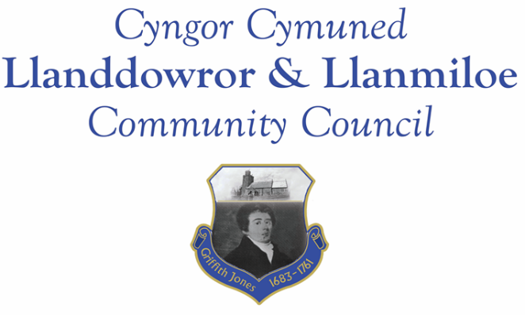
NOTICE OF MEETING

To All Members of Llanddowror & Llanmiloe Community Council.
I hereby summon you to attend the meeting of the Council, starting at 7.00pm on Monday 14th April 2025, for the transaction of the business outlined in the agenda below.
This meeting will be held in Llanmiloe Resource Centre.

Vicky Mitchell – Clerk
Agenda

1. Apologies for absence.

2. Declaration of personal and prejudicial interests.

3. Questions from members of the public regarding items on the agenda.

4. Adoption of previous minutes of meeting held on 10th March 2025.

5. County Councillor’s report, including on matters raised in previous meetings. Queries to the County Councillor raised by those present. From March: any update on Highways query re street-parked vehicles in Llanddowror raised in Jan. Also PEDW decision?

6. Clerk’s report.

7. Matters ongoing from previous minutes requiring discussions or decisions, not covered above:

8. New business.
- Complaints about state of area between Duke’s Meadow and Wood End from local residents.
- Annual report of the Council for 2024-25 – to consider for adoption.
- Request for donation to Llanmiloe School PTA for community VE celebration 3rd May. Message 26-3-25
- Request for donation towards Llanmiloe School building of outdoor classroom.

9. Financial Report
- Current financial situation: Financial report appended to agenda for Councillors.
- Income received since last meeting: £0.00

- Invoices to pay:
- Clerk monthly salary and expenses – April.
- HMRC monthly payments – April.
- Dwr Cymru - £10.50 (direct debit) per month.
- British Gas Lite – variable direct debit each month – £XXX to pay in April
- BLC – toilet cleaning April - £64.00.
- Hugofox – website hosting payment – monthly direct debit £11.99

10. Significant correspondence.
- One Voice Wales training opportunities.
- VE80 wreath offer.

Any other correspondence received prior to meeting but after the date of publication of this agenda will be brought to the attention of the meeting for consideration.

11. Planning matters.

Any planning received prior to meeting but after the date of publication of this agenda will be brought to the attention of the meeting for consideration.

12. Councillors’ reports for information or items for next meeting.

13. Date of next meeting – 12th May 2025.

12th May 2025 Llanddowror 9th June 2025 Llanmiloe
8th September 2025 Llanddowror 13th October 2025 Llanmiloe
10th November 2025 Llanddowror 8th December 2025 Llanmiloe
12th January 2026 Llanddowror 9th February 2026 Llanmiloe
9th March 2026 Llanddowror 13th April 2026 Llanmiloe
11th May 2026 Llanddowror 8th June 2026 Llanmiloe
14th September 2026 Llanddowror 12th October 2026 Llanmiloe

Meetings to be either in Llanmiloe Resource Centre, with hybrid access via Zoom provided as required, or in Llanddowror Meeting Room, or fully via Zoom.
~~~~~~~~~~~~~~~~~~~~~~~~~~~~~~~~~~~~~~~~~~~~~~~~~~~~~~~~~~~~~~~~~~~~~~~~~~

