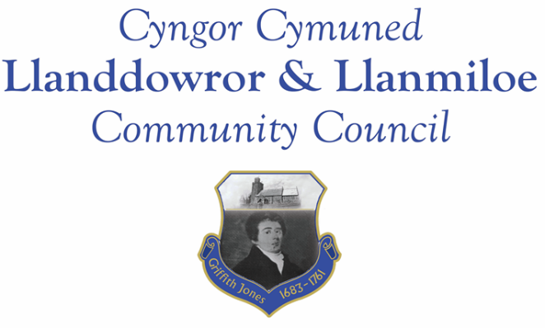

NOTICE OF MEETING

To All Members of Llanddowror & Llanmiloe Community Council
I hereby summon you to attend a meeting of the Council, to be held at various locations from 7.00pm on Monday 12th October 2020, for the transaction of the business outlined in the agenda.

Vicky Mitchell – Clerk

AGENDA

1. Apologies for absence.

2. Declaration of personal interests.

3. Adoption of previous minutes – 14th September 2020

4. County Councillor’s report – if able to attend, otherwise by email.

5. Matters ongoingfrom previous minutes.
- Meeting Room water channel.
- CAVS post covid-19 funding.
- Councillor vacancies.

6. New business
- Appointment of Vice-Chairman.
- Community activities to raise profile of Community Council.
- Added Wed 7-10-20 – wreath laying – email from Roy Watkins – sent to all am.

7. Financial Report
- Current financial situation. Financial report circulated before meeting.
- Invoices to pay – Clerk monthly salary and expenses.
Monthly HMRC payments.
Dwr Cymru - £13.50 (direct debit)

8. Correspondence.
- St Peter’s church virtual Christmas Fayre.
- OVW online training.
- IRPW draft annual report

9. Planning matters. No new applications had been received by the date of agenda publication. Any received prior to meeting will be brought to the attention of the meeting for consideration.

W/40767 – revised application submitted 25th September – Councillors notified, information placed on website.

PL/00339 – single storey extension on front elevation 52 Llanmiloe Estate. Recd and passed on 7-10-20 – after

10. Councillors’ reports for next meeting.

11. Date (and venue) of next meeting.

