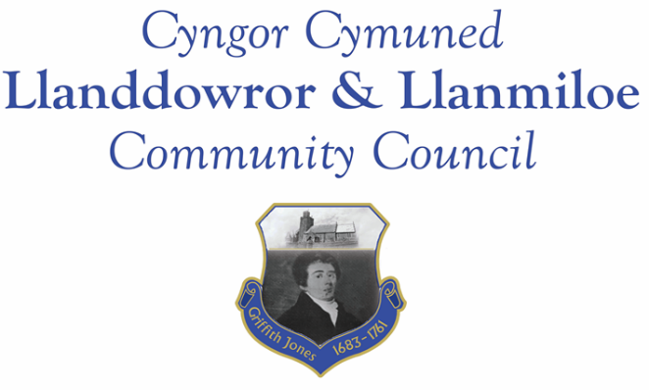
Minutes of the normal meeting of Llanddowror and Llanmiloe Community Council
Held in the various locations via Zoom, Monday 8th March 2021.

Present Cllrs Terence Langdon, Sandra Hewens, David Howells, Chris Holt, Gwyn Owen and County Cllr Jane Tremlett.
Apologies. These were received from Cllrs Phill Pickersgill, Catrin Davies and Nigel Hodson.
Declarations of personal interests. Cllrs Hewens and Pickersgill declared a personal interest in the flooding in Llanmiloe topic.
Adoption of previous minutes. The minutes of the meeting of 8th February 2021 had been previously circulated. The minutes were accepted as a true record and would be duly signed at the earliest opportunity – proposed Cllr Howells, seconded Cllr Hewens and agreed by all.
County Cllr’s report. Cllr Jane Tremlett went through the various issues that had been raised in detail, and they were discussed in turn.
Flooding report. Cllr Tremlett reported that this had gone to the relevant departments including Planning, Highways and the technical departments. She stated that the Planning Enforcement Officer had been out to inspect potential irregularities already.
She also stated on the Bwlchnewydd post box topic, which was on the agenda, that she had received information from Royal Mail that that particular box had been removed because it was significantly underused. It was agreed that it would have been a courtesy by Royal Mail to make that information public. The Clerk would convey this information to the resident who raised the issue.
Matters ongoing from previous minutes:
- Meeting Room water channel. The Clerk had contacted other potential contractors and was hoping to receive a quote in the coming week.
- Councillor vacancies. Councillors agreed to keep seeking potential candidates.
- Community activities by the Council. The Clerk reported that the CAVS covid-19 grant period had been extended to August 2021.
- Flooding in Llanmiloe. This had been covered in the County Councillor’s section.
New business:
- Carmarthenshire Antiquary Society – Griffith Jones legacy. The Society had contacted the Council about their plans. Information on the plaque put at the Church by the Village Association had been passed on to them.
- Bwlchnewydd post box. This had been discussed earlier in the meeting.
- Broadband Upgrade Fund. The Clerk summarised the situation, stating that a resident had suggested that the Community Council should take on the role of Community Co-ordinator. The matter was discussed, and a Cllr volunteered to contact the residents concerned to see if there could be any help offered by the Council. The Clerk would accordingly contact the resident who raised the matter.
- Public footpath to Newton. The Council were informed that a resident had raised concerns about the ford footpath crossing, but that this was hopefully being resolved. If there continued to be issues the Clerk would contact CCC to request a repair be undertaken.
County Cllr Jane Tremlett left the meeting at this point. It was agreed that any issues to raise with her from the rest of the meeting would be passed on by the Clerk.
Financial report:
An up to date report on the finances of the Council had been previously circulated, and was accepted as accurate. The Clerk stated that she had been unable to set up a standing order or direct debit for the Danfo payments due to limitations of the bank mandate.
The following invoices were noted, and agreed for payment – proposed by Cllr Howells, seconded by Cllr Hewens and agreed by all:
- Clerk monthly salary and expenses.
- Clerk monthly tax payment.
- Dwr Cymru direct debit £13.50 monthly.
- Danfo – toilet cleaning contract - £84.00 for February.
Correspondence
Items of correspondence since the last meeting had been forwarded upon receipt. Specific items to note were:
- One Voice Wales remote training opportunities in March. This was noted.
- Welsh Government flytipping consultation. This was discussed and noted. The Clerk was asked to follow up on the flytipped waste by the side of the main road in Llanmiloe near the school and MoD entrances.
- Carmarthenshire County Council Chairman’s Appeal. This was discussed, and it was agreed to donate £25.00 for the Prostate Cancer charity he was supporting.
- St David’s Day celebrations – Friends of St Peter’s. This was noted.
- Local Government and Elections (Wales) Act 2021. The list of relevant topics provided by One Voice Wales was noted.
Planning matters:
PL/01261. Non material amendments to PL/00339. 52 Llanmiloe Estate. This had been granted.

Councillors’ reports for next meeting.
Cllr Hewens raised the issue of a blocked drain in Llanmiloe. The Clerk would inform CCC and request that the blockage be sucked out and then the full drain system in that area be flushed to ensure no blockage remained.
Cllr Hewens also raised the issue of road safety in the Bro Myrddin part of Llanmiloe, where increasing numbers of parked cars on the narrow road were obstructing traffic, plus the growing number of caravans being parked. The Clerk would contact Bro Myrddin on these matters.
Cllr Howells suggested that CCC be offered the bollarded off section adjacent to the Meeting Room in Llandowror for placement of a bottle bank. This was agreed as a potential option by the Council, and the Clerk asked to contact CCC accordingly.
The Clerk stated that the Meeting Room had been booked for the elections on 6th May.
Date and venue of next meeting
The next meeting was planned for 12th April 2021, most probably via Zoom. The Clerk would call a meeting beforehand if it was required.
There being no further business the meeting concluded at 8.15pm.

