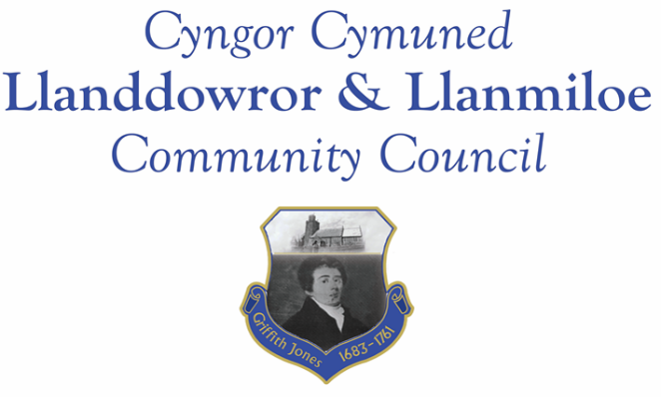

NOTICE OF MEETING

To All Members of Llanddowror & Llanmiloe Community Council.
I hereby summon you to attend a meeting of the Council, to be held at various locations from 7.00pm on Monday 11th January 2021, for the transaction of the business outlined in the agenda.

Vicky Mitchell – Clerk
AGENDA

1. Apologies for absence.

2. Declaration of personal interests.

3. Adoption of previous minutes – 14th December 2020

4. County Councillor’s report.

5. Matters ongoing from previous minutes.
- Llanddowror speed limits – feedback from community.
- Meeting Room water channel.
- Councillor vacancies.
- Llanddowror bottle bank trial.
- Community activities by Council.

6. New business
- Issues raised with CCC since last meeting: flooding of property Llanmiloe; tanker activity in and around New Mill to St Clears area – damage to verges, possible slurry.
7. Financial Report
- Current financial situation. Financial report appended to agenda.
- Invoices to pay – Clerk monthly salary and expenses.
HMRC monthly payments.
Dwr Cymru - £13.50 (direct debit)
Danfo - £84.00 – toilet cleaning

8. Correspondence.
- One Voice Wales training opportunities.
- Precept request from CCC- responded with amount agreed in last meeting.
- Census Engagement Officer email.

9. Planning matters. Any received prior to meeting but after the date of publication of this agenda will be brought to the attention of the meeting for consideration.

10. Councillors’ reports for next meeting.

11. Date of next meeting.

