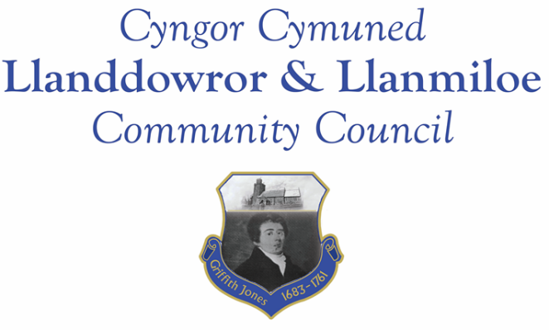

NOTICE OF MEETING

To All Members of Llanddowror & Llanmiloe Community Council
I hereby summon you to attend a meeting of the Council, to be held at various locations from 7.00pm on Monday 9th November 2020, for the transaction of the business outlined in the agenda.

Vicky Mitchell – Clerk

AGENDA

1. Apologies for absence.

2. Declaration of personal interests.

3. Adoption of previous minutes – 12th October 2020

4. County Councillor’s report – if able to attend, otherwise by email.

5. Matters ongoingfrom previous minutes.
- Meeting Room water channel.
- Appointment of Vice-Chairman.
- Councillor vacancies.
- Llanddowror bottle bank trial.
- Community activities by Council including seating in Pocket Park.

6. New business

7. Financial Report
- Current financial situation. Financial report circulated with agenda.
- Invoices to pay – Clerk monthly salary and expenses.
Monthly HMRC payments.
Dwr Cymru - £13.50 (direct debit)
Swalec - £87.32 (direct debit – quarterly)

8. Correspondence.
- Welsh Govt consultation on draft regulations for 4 regional Corporate Joint Committees in Wales – forwarded 13-10-20
- Welsh Govt consutation on Strategic Development Plans for use by the CJCs mentnioed above – forwarded 13-10-20
- Welsh Govt National Strategy for flood and coastal erosion risk management in Wales - forwarded 22-10-20
- One Voice Wales remote training opportunities in November.
- Electroal Refrom newsletter.

9. Planning matters. No new applications had been received by the date of agenda publication. Any received prior to meeting will be brought to the attention of the meeting for consideration.

10. Councillors’ reports for next meeting.

11. Date of next meeting.

