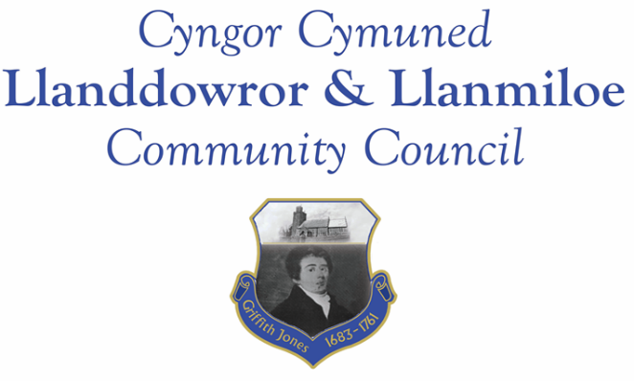
NOTICE OF MEETING

To All Members of Llanddowror & Llanmiloe Community Council.
I hereby summon you to attend the meeting of the Council, starting at 7.00pm on Monday 11th December 2023, for the transaction of the business outlined in the agenda below.
This meeting will be held in Llanmiloe Resource Centre.

Vicky Mitchell – Clerk

Agenda

1. Election of Chairman for Council

2. Apologies for absence.

3. Declaration of personal and prejudicial interests.

4. Questions from members of the public regarding items on the agenda.

5. Adoption of previous minutes of meeting held on 13th November 2023.

6. County Councillor’s report, including on matters raised in previous meetings. Queries to the County Councillor raised by those present.

7. Clerk’s report.

8. Matters ongoing from previous minutes requiring discussions or decisions, not covered above:

9. New business.
- Consider the traffic messaging changes proposed for Llanddowror. Email 28-11-23
- Consider the proposed budget (previously circulated) for this Council for 2024-25.
- Consider what precept to request from Carmarthenshire County Council for 2024-25
10. Financial Report
- Current financial situation: Financial report appended to agenda.
- Income received: £0.00

- Invoices to pay:
- Clerk monthly salary and expenses – December.
- HMRC monthly payments – December.
- Dwr Cymru - £50.00 (direct debit) per month.
- British Gas Lite – variable direct debit each month – £27.53 in December
- BLC – toilet cleaning December - £64.00.

11. Significant correspondence.
- One Voice Wales training opportunities.

Any other correspondence received prior to meeting but after the date of publication of this agenda will be brought to the attention of the meeting for consideration.

12. Planning matters.

PL/

Any planning received prior to meeting but after the date of publication of this agenda will be brought to the attention of the meeting for consideration.

13. Councillors’ reports for information or items for next meeting.

14. Date of next meeting – 8th January 2024.
~~~~~~~~~~~~~~~~~~~~~~~~~~~~~~~~~~~~~~~~~~~~~~~~~~~~~~~~~~~~~~~~~~~~~~~~~~

Meeting dates for 2023-2024:

11th December 2023
8th January 2024 12th February 2024
11th March 2024 8th April 2024
13th May 2024 10th June 2024
9th September 2024 14th October 2024
11th November 2024 9th December 2024
Meetings to be either in Llanmiloe Resource Centre, with hybrid access via Zoom provided as required, or in Llanddowror Meeting Room, or fully via Zoom.

