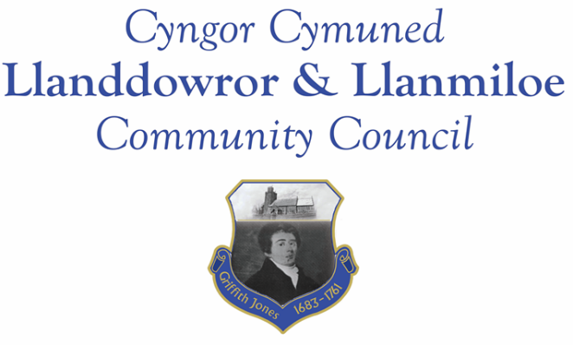

NOTICE OF MEETING

To All Members of Llanddowror & Llanmiloe Community Council.
I hereby summon you to attend a meeting of the Council, to be held by Zoom from 7.00pm on Monday 8th November 2021, for the transaction of the business outlined in the agenda below.

Vicky Mitchell – Clerk

1. Apologies for absence.

2. Declaration of personal interests.

3. Adoption of previous minutes – 11th October 2021.

4. County Councillor’s report, including on matters raised in previous meeting, specifically:
- Flooding report – feedback and actions taken/to be taken by CCC
- Speed reduction measures – CCC viewpoint on picket gate installation; flashing speed signs. Provision by CCC, permitted on Highways land, etc.

5. Matters ongoing from previous minutes.
- Meeting Room water channel.
- Councillor vacancies.
- Flooding issues in Llanmiloe – to receive any updates.
- Meeting Room door – to receive any updates.
- Llanmiloe noticeboard – to receive information regarding repairs required.
- Meeting Room use – note Jazz Band no longer using premises – too small.
- Wifi for Meeting Room – update from Clerk.

6. New business.
- Llanmiloe School – Additonal Community Governor.
- CCC Christmas toybox appeal. Email recd 26-10-21
- Resurfacing in Llanmiloe – issues with contractors – hopefully resolved.
- Meeting with police regarding anti-social behaviour in Llanmiloe area.

7. Financial Report
- Current financial situation. Financial report appended to agenda.
- Income received - £20 – jazz group MR hire 4-10-21
- Invoices to pay – Clerk monthly salary and expenses – November.
HMRC monthly payments – November.
Dwr Cymru - £16.50 (direct debit) per month
Swalec – quarterly direct debit - £39.90
Danfo - £84.00 - toilet cleaning
Taf Building Supplies - replacement valve for MR toilet - £15.54

8. Significant correspondence.
- One Voice Wales training opportunities..
- Royal British Legion – St Clears Branch – thank you letter for donation.

Any other correspondence received prior to meeting but after the date of publication of this agenda will be brought to the attention of the meeting for consideration.

9. Planning matters.

Any planning received prior to meeting but after the date of publication of this agenda will be brought to the attention of the meeting for consideration.

10. Councillors’ reports or items for next meeting.

11. Date of next meeting – 13th December 2021.

~~~~~~~~~~~~~~~~~~~~~~~~~~~~~~~~~~~~~~~~~~~~~~~~~~~~~~~~~~~~~~~~~~~~~~~

