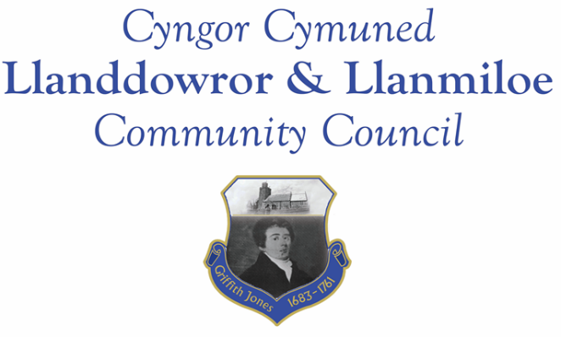

NOTICE OF MEETING

To All Members of Llanddowror & Llanmiloe Community Council.
I hereby summon you to attend a meeting of the Council, to be held by Zoom from 7.00pm on Monday 11th October 2021, for the transaction of the business outlined in the agenda below.

Vicky Mitchell – Clerk

1. Apologies for absence.

2. Declaration of personal interests.

3. Adoption of previous minutes – 12th September 2021.

4. County Councillor’s report, including on matters raised in previous meeting, specifically:
- Flooding report – feedback and actions taken/to be taken by CCC
- Speed reduction measures – CCC viewpoint on picket gate installation; flashing speed signs. Provision by CCC, permitted on Highways land, etc.

5. Matters ongoing from previous minutes.
- Meeting Room water channel.
- Councillor vacancies.
- Flooding issues in Llanmiloe – to receive any updates.
- Meeting Room door – to receive any updates.
- Llanmiloe noticeboard – to receive information regarding repairs required.
- Llanddowror bridge and road damage – to receive any updates.

6. New business.
- Remembrance Day arrangements – including purchase of wreaths.
- Firework displays in the community – to receive information on any plans.
- Potential LEADER funding – wifi – to discuss and decide whether to proceed.
- Llanddowror – overhanging tree - to note this has been reported to CCC.
- OVW Carmarthenshire area next meeting 27-10-21 – to note date.

7. Financial Report
- Current financial situation.
- Income received - None at date of agenda publication
- Invoices to pay – Clerk monthly salary and expenses – October.
HMRC monthly payments – October.
Dwr Cymru - £13.50 (direct debit) per month
Danfo - £ (invoice expected) - toilet cleaning

Note - £100.00 transferred from main account 28-9-21 to second account in order to retain it as an active account.

8. Significant correspondence.
- One Voice Wales training opportunities..
- Welsh Govt TAN15 on planning and future flooding maps.

Any other correspondence received prior to meeting but after the date of publication of this agenda will be brought to the attention of the meeting for consideration.

9. Planning matters.
PL/02663. Two bedroom extension to front elevation of building. 71 Llanmiloe Estate, Llanmiloe. SA33 4EU. Recd by LLCC – 14-9-21.

Any other planning received prior to meeting but after the date of publication of this agenda will be brought to the attention of the meeting for consideration.

10. Councillors’ reports or items for next meeting.

11. Date of next meeting – 8th November 2021.

