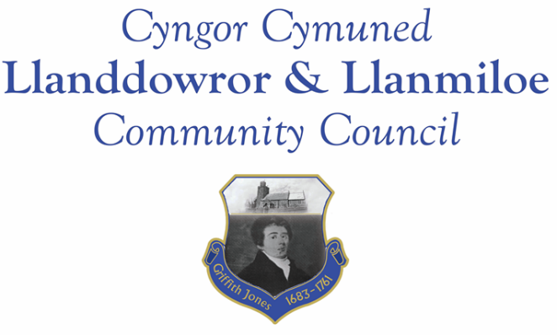
Minutes of the meeting of Llanddowror and Llanmiloe Community Council
Held in Llanddowror Meeting Room, Monday 9th December 2019.

Present: Cllr Phill Pickersgill (Chair), Cllrs Cllrs Sandra Hewens, Chris Holt, Gwyn Owen, Nigel Hodson and County Cllr Jane Tremlett.

- Apologies for absence: Apologies were received from Cllrs David Howells, Angela Crewes, Jamie Rugg and Terence Langdon.

- To disclose personal and pecuniary interests. No personal interests were declared.

- To review and agree the minutes of the previous meeting on 11th November. These had been previously circulated, and were accepted as a true record by all.

- County Councillor’s report. Cllr Jane Tremlett had previously provided an update on the issues that had been raised in the last meeting. The broken kerb by the bus shelter was listed for repair; the drain issue in Cysgod Y Coed in Llanmiloe had been logged for attention, as had the drain opposite the church in Llanddowror. The latter potentially could be as a result of a blockage further down the pipe system. She had been due to receive a report on the traffic calming in Llanddowror but had not yet done so – she would follow up on this. She did suggest that the Council approach Eglwyscummin Community Council about joint working on this since they were concerned at traffic speeds in Red Roses. She also mentioned a three county initiative which she would bring more information and talk about at the next meeting.

Concerns were raised about the ongoing heavy traffic for the Pendine work, which was likely to be causing the road to deteriorate. There was also concern expressed about the damaged sleeping policemen outside the medical centre in Llanmiloe. Cllr Tremlett stated that she would raise both of these as a concern within CCC.

Cllr Tremlett then left the meeting.

- Matters ongoing from previous minutes.

- Drainage channel. The contractor would be contacted again about this.
- Chair plaque. Cllr Holt reported he was still trying for some suitable quotes for the provision of this.
- Welsh Water – Llanddowror issues. There had been some emergency work in the village in the last week, plus various households had been contacted so there was some active sewer investigation going on.
- Noticeboards. The Llanmiloe one had yet to be removed and treated. It would be done as soon as possible.
- Concerns raised with County Cllr in previous meetings. These had been covered earlier in the meeting.
- A477 junction map work. This had not yet been done, but should be done soon.
- Llanmiloe soil waste. This was waiting on either this Council being able to provide transport, or arrangements with CCC when they were on site. It was agreed that it would be helpful to have a plan or map in advance indicating exactly where the soil should go – Cllr Rugg would be consulted.
- St Clears station – Cllr Howells attended, but no report had been provided for this meeting.

- New business.
- Llanddowror toilet. Cllr Pickersgill summarised the incident: the door lock had been damaged, possibly vandalised, and the whole interior of the toilet had been seriously soiled. It was thought it could have been an accidental event from the Welsh Water sewer work, but it was not. The interior had been pressure hosed clean, and the lock replaced. The toilet was used by delivery drivers, and so might remain open through the winter. Cllrs Pickersgill and Howells would ensure the toilet was properly cleaned and repaint as necessary.
- Council budget and precept for 2020-21. The Clerk had previously circulated a summary report and talked the Council through it. After discussion it was agreed that greater clarity on the reserves held were wanted – the Clerk would provide this information. Provisionally a sum for the budget and precept was agreed, subject to the matter of the reserves. It was agreed after a discussion that the Clerk should investigate and price up the options for a new printer, and for an external hard drive for backup purposes.

- Financial matters.
The current and predicted financial situation for the Council had been provided in the previous item. The Clerk stated that the bank mandate change was in progress - further information was required.

Invoices presented for payment: Clerk salary and expenses for December
Clerk tax for December
Dwr Cymru direct debit for December - £9.50

- Correspondence:

- Welsh Govt consultation: A more equal Wales – commencing socio-economic duty.
- Dyfed Powys Police precept consultation,

- Planning matters:

Application W/39885. Construction of two storey extension and detached garage/equipment store. CNWC, Llanddowror. Cllrs could not state their opinion on this application because they were unaware of the location as described.

Application W/39585. Granted. Discharge of planning conditions on W/38569 (change of use of existing barns into holiday let accommodation) – photographic survey of existing buildings and designs for proposed windows and doors. Brook House Farm, Laugharne.

- Councillor’s reports and information for next meeting:

The Council had been informed of the sudden death of Cllr Crewes’ mother. It was agreed that a letter of condolence should be sent.

It was stated that a bin on the Bro Myrddin estate towards Westmead Close on the route to the school was frequently full and debris being left around it. The Clerk would contact Bro Myrddin about providing a larger bin, and ensuring waste that spilled over was collected.

Concern was also expressed about the pills in and around the MoD site that had yet to be drained. The sides of the pill had to be visible before any dredging was done to ensure no damage was done because it was a known vole habitat. The unusually large amount of rainfall in late summer and autumn meant that the dredging had not yet taken place, but it would be done as soon as possible.

- Date and venue of next meeting. This was agreed to be Llanmiloe Resource Centre on Monday 13th January , starting at 7.00pm.

There being no further business, the meeting closed at 8.20pm.

