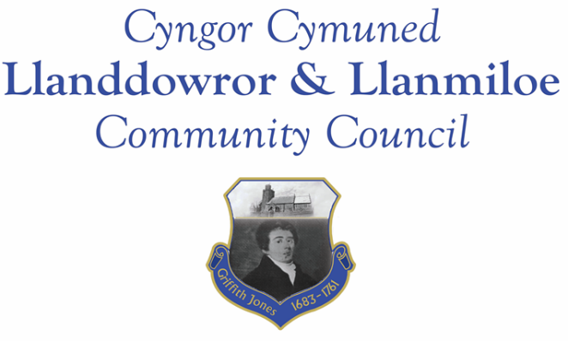

Minutes of the normal meeting of Llanddowror and Llanmiloe Community Council
Held in via Zoom, Thursday 18th August 2022.

Present Cllrs, Sandra Hewens (Chairman), David Howells. Terence Langdon, Eric Haines, Nigel Hodson.
- Apologies. There were no apologies received.
- Declarations of personal interests. No interests were declared.
- Questions from members of the public regarding agenda items. There were no members of the public in attendance.
- Consideration of the potential Llanmiloe pill clearance project. The estimate provided by the one contractor had been previously circulated. This was discussed, and considered too high a cost for this Council to incur – potentially acceptable if the action was a one-off, but if as could be possible it would be required annually it would mean a significant increase in the precept as paid by residents, plus could lead to potential legal liability should any issues occur.
This Council would really like to get this work done, to reduce flooding risks and also stop the pill further becoming a general dumping ground and eyesore. However, the cost was prohibitive and it was agreed that the work needed significant actual input from and taking of ownership by the organisations who were responsible for the pill, so most likely MoD, CCC or both. It was not the responsibility of this Council to undertake this work. It was also stated that LCDA volunteers had undertaken the relevant work on their land in the last fortnight.
It was stated that CCC periodically opened the 32 gutter openings from the highway to drain into this pill, and that the Coastal Path that ran in the vicinity of Westmead Close was alongside it, which suggested there was likely some CCC responsibility for it.
It was proposed and agreed that the Clerk should write to the County Councillor Jane Tremlett requesting that she definitely find out who was responsible for maintenance of that pill, and request that work be done to clear it before the coming winter and risks of flooding in the local community occur.
The Clerk was also to organise a site meeting with the County Cllr, the relevant Highways Officer and Llanmiloe Councillors to discuss the issue, and also the recent tree/hedge trimming, which was considered inadequate – the trimming stopped at a level which meant buses were unable to pass each other safely.
- Date and venue of next meeting
The next meeting was planned for September 12th 2022. It was agreed to plan to have this in person in Llanmiloe Resource Centre with remote access enabled for those who wished it.
There being no further business the meeting concluded at 7.25pm.

