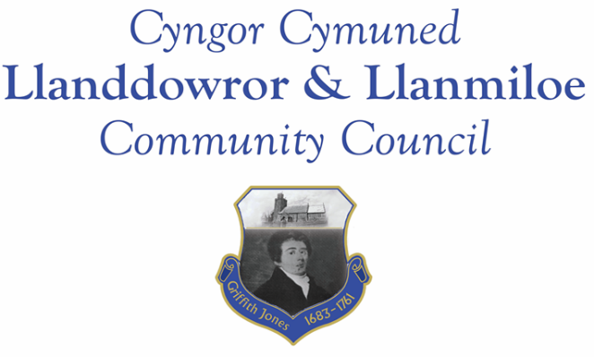

Minutes of the normal meeting of Llanddowror and Llanmiloe Community Council
Held Monday 12th December 2022.

Present Cllrs Sandra Hewens (meeting Chairman), Terence Langdon, , David Howells, Eric Haines, Nigel Hodson, Leigh Clarkson, County Cllr Jane Tremlett and a member of the public.
- Apologies. There were no apologies received.
- Declarations of personal interests. Cllr Clarkson declared an interest in one financial item.
- Questions from members of the public regarding agenda items. The member of the public raised their ongoing concerns regarding the existing planning enforcement case in Llanddowror and their related concerns regarding speeding traffic through the village. Both items had been previously raised a number of times by the Council with CCC and GoSafe. The concerns were noted.
- Adoption of previous minutes for the normal meeting on 14th November 2022. These were agreed by all, and duly signed by the Chairman.
- County Councillor’s report: County Cllr Tremlett stated that she was still trying to arrange a site meeting, but the relevant officer was not responding. She agreed to have a site meeting with community councillors and interested members of the public to provide information on the situation. Cllr Tremlett also provided information on the council tax base for the community, and the upcoming public consultation on Carmarthenshire’s budget. There was no new information on the provision of sandbags and a container.
- Clerk’s report. The Clerk had previously circulated the report. It was noted that the issues were mostly awaiting action or information from CCC officers.
- Matters ongoing from previous minutes:
- Community projects: the two community associations were working on their potential bids for play equipment funding.
- Llanddowror Old Café site. This had been extensively discussed during the public participation section of the meeting. It was agreed that it was an ongoing concern, with residents feeling increasingly disillusioned with the handling of it by CCC. It was agreed that the Clerk should put in an official complaint about the lack of progress and indeed resolution over the last two years.
- Llanddowror Meeting Room donations box. This was in progress.
- New business:
- The Clerk had provided a draft budget with explanatory information to all Cllrs. This was discussed in detail and some amendments were made. The rising cost of utilities which would affect the Meeting Room costs and streetlight costs, for instance were considered, as well as insurance, and wishing to continue providing visible benefits to and in the community.
- The Council then considered the amount of precept to request in the light of the agreed budget for 2023-24. The sum of £13500 was agreed for the year.

9. Financial Report
The current financial situation was provided to all Cllrs.
- Income received: No income had been received since the last meeting.
- Invoices to pay:
- Clerk monthly salary and expenses – December.
- BLC – toilet cleaning December - £80.00. Cllr Clarkson declared an interest in this item
- HMRC monthly payments – December.
- Dwr Cymru - £20.50 (direct debit) per month.

10. Significant correspondence.
- One Voice Wales training opportunities. This was noted.

11. Planning matters.
PL/05172 - Proposed erection of a single new dwelling on an existing residential development. Plot 4, Dan Y Bryn, Pendine, SA33 4UG. Application registered 8/12/2022. There were no objections so long as the dwelling was build no more than two storeys high and was in keeping with the existing and planned dwellings in the area.

12. Councillors’ reports for information or items for next meeting.
Cllr Hewens stated that the bus stop by the old club was still surrounded by sludge and fallen leaves, The Clerk had reported this for cleansing, but it had not been done. The Clerk would chase up on it.
In addition a letter from local residents concerned at the access to the local postbox was raised. The Clerk would contact CCC to see what could be done.
Cllr Haines raised a suggestion of donating to the School’s PTA to assist with bike rack and football post provision – this would be discussed in the next meeting once they had provided potential costs.
It was also suggested that grit bins be provided in both communities. The Clerk would contact CCC to find out prices and options from them for the January meeting.
Cllr Howells reported that a vehicle had caused a drain to be blocked on the road out of Llanddowror towards Taversnpite. The Clerk would report this to CCC.
13. Date of next meeting – 9th January 2023.
There being no further business the meeting concluded at 8.45pm

