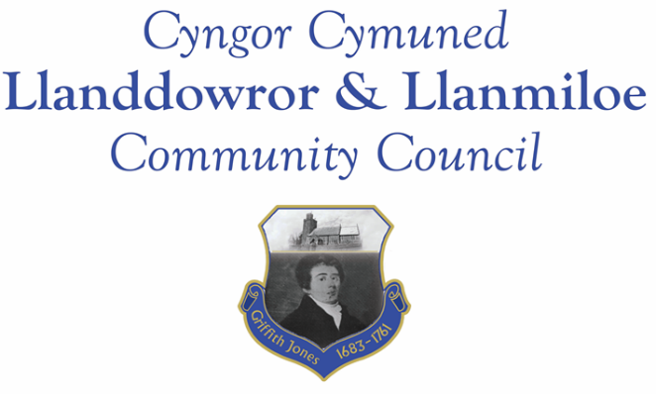
Minutes of the normal meeting of Llanddowror and Llanmiloe Community Council
Held in the various locations via Zoom, Monday 14th September 2020.

Present Cllrs Chris Holt, Gwyn Owen, Phill Pickersgill, David Howells and County Cllr Jane Tremlett.
Apologies. These were received from Cllrs Angela Crewes, Terence Langdon, Sandra Hewens, Nigel Hodson. Their reasons for absence were accepted.
Declarations of personal interests. There were none received.
Adoption of previous minutes. The minutes of the meetings of 8th June and 6th July had been previously circulated. The minutes were accepted as a true record and would be duly signed at the earliest opportunity – proposed Cllr Pickersgill, seconded Cllr Howells and agreed by all.
County Cllr’s report. County Cllr Tremlett stated that social care and the ongoing covid-19 situation had taken up a lot of her time in the past few months, and there were concerns in CCC that the transmission rate was on the increase.
On the topics that had been raised with her previously: Llanmiloe speed humps – this had been dealt with; Llanmiloe road edges – these were being monitored on a regular basis by CCC officers; Llanmiloe kerbstones gaps – these had been filled; Llanmiloe safety road markers – these had been replaced; Llanddowror speed check explanatory information – despite requesting it, this had not yet been supplied.
It was asked in relation to the latter whether the speed limit could be reduced to 20mph through the village of Llanddowror. Cllr Tremlett stated she would enquire whether this could be possible, and Cllrs agreed to consult the residents to see if they were in favour of this idea – it would be discussed in the next meeting. It was emphasised that to have the speed data provided in a meaningful way was important, even though the results that had been provided suggested speeds well beyond the legal limit were happening on a regular basis.
Matters ongoing from previous minutes:
- Meeting Room water channel. The contractor was not responding to attempts to contact him on this matter.
New business:
- Resignation of Cllr Crewes. This had been received on the day of the meeting. With regret this was accepted by the Council, and it was agreed to send a letter of thanks to her for her years of service. The resignation of Cllr Rugg soon after the previous meeting had also been accepted with regret.
- Ratification of the decision to re-open Llanddowror public toilets. This had been made after Government restrictions had eased and various potential contractors had provided prices for professionally cleaning the toilets on a regular basis. The contract had been awarded and the toilet opened soon afterwards. It would be considered in a later meeting whether the usage, which appeared to be mainly by deliverymen outside of holiday season, justified the costs.
- Llanddowror bottle bank. The bottle bank that had been located adjacent to Llanddowror Meeting Room had been removed by CCC because there was inadequate safe access for emptying it. The Council was aware that residents were having difficulties getting to other locations to safely dispose of bottles. Council requested that the County Cllr find out whether it would be possible to place a couple of bottle banks on the old road that was now a layby adjacent to the old rectory, on a three month trial basis to see how well it was used.
- Remembrance Day – wreaths and arrangements. It was agreed to purchase two wreaths as last year, and to also check with the Royal British Legion what the arrangements would be for this year – the Clerk would contact them accordingly.
- Picton Monument in Carmarthen. CCC currently had a consultation running asking for views on this. It was discussed and agreed that the Clerk should put in a response from the Council.
Financial report:
An up to date report on the finances of the Council had been previously circulated. The receipt of the precept portion of £6033.33 was noted, as was the apology payment of £50.00 from the company who arranged the new electricity contract. The Clerk also reported on the grant from Carmarthenshire Covid-19 Support Fund. It was agreed that this should be accepted, and within the terms of the grant spent as best benefitted the community to support them at this covid-19 time.
The following invoices were noted, and agreed for payment – proposed by Cllr Owen, seconded by Cllr Howells and agreed by all:
- Clerk monthly salary and expenses.
- Clerk monthly tax due.
- Dwr Cymru direct debit £13.50 monthly
- Swalec – direct debit - £48.73
Correspondence
Items of correspondence since the last meeting had been forwarded upon receipt. There had been nothing requiring addition to the agenda for discussion or decision-making.
Planning matters:
Planning application PL/00027. Forestry area , Llanddowror – improvement of the access and creation of a turning and loading area. There were no objections to this – the Clerk would respond accordingly.
Councillors’ reports for next meeting.
Cllr Holt raised the issue of there being no current vice-Chairman. It was agreed to discuss this in the October meeting.
Cllr Howells stated that the covid-19 situation meant that people were staying in their communities far more. He asked whether it would be possible for the Council to do more for their communities at this time, and looking towards the future. This would be discussed in the October meeting.
Cllr Owen stated that there had been recent investigations by environmental officers in and around the pills in Llanmiloe, and no evidence of water voles had been found. He would pass on to the Clerk contact details and any other information so that this could be provided to NRW and the MoD with any requests to dredge and clear out the pills. Although the majority are on MoD land, NRW was a legal duty in perpetuity to clean the major ones.
Date and venue of next meeting
The next meeting was planned for October 12th, most probably via Zoom, depending upon Government restrictions. The Clerk would call a meeting beforehand if it was required.
There being no further business the meeting concluded at 8.10pm.

