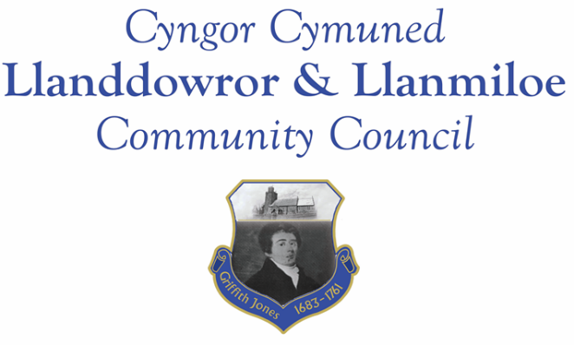

NOTICE OF MEETING

To All Members of Llanddowror & Llanmiloe Community Council.
I hereby summon you to attend a meeting of the Council, to be held by Zoom from 7.00pm on Monday 13th September 2021, for the transaction of the business outlined in the agenda below.

Vicky Mitchell – Clerk

1. Apologies for absence.

2. Declaration of personal interests.

3. Adoption of previous minutes – 14th June 2021.

4. County Councillor’s report. Some matters may overlap with those listed below.

5. Matters ongoing from previous minutes.
- Meeting Room water channel.
- Councillor vacancies.
- Flooding issues in Llanmiloe – to receive any updates.
- Meeting Room door – to receive any updates.

6. New business.
- Biodiversity policy and plan – to review.
- Llanddowror – to consider issues with slurry tanker convoys, road depression, potential bridge damage and decide whether further action needs to be taken by this Council. Issue raised 28-7-21
- Carmarthenshire Antiquarian Society – Carmarthenshire Enlightment project – to consider what actions to be taken by this Council – email 15-8-21.
- Llanmiloe noticeboard - to consider repair/replacement for lower edge.
- Llanddowror – dog fouling – to consider purchase and placement of signs if possible. Raised with CCC 4-9-21

7. Financial Report
- Current financial situation. Financial report appended to agenda.
- Income received - £6025.33 – second tranche of precept
- Invoices to pay – Clerk monthly salary and expenses – July, August, September.
HMRC monthly payments – July, August, September.
Dwr Cymru - £13.50 (direct debit) per month
Danfo - £105.00 June; £84.00 July; £?84.00 August (invoice expected)
– toilet cleaning

8. Significant correspondence.
- One Voice Wales training opportunities. Assumed.
- CCC consultation on 10 year Housing and Regeneration masterplan - open June 14th to July 26th
- CCC consultation on waste collection strategy – open June 14th until July 7th.
- Welsh Water work in Llanddowror between July and October – letter received 29-6-21
- Boundary Commission for Wales final reommendations report – recd 8-7-21
- Welsh Government consultation – changes to local elections procedures at County and Community level – closes 24th September.
- CCC Active Travel consultat8ion – open until end of October – email 30-8-21.

Any other correspondence received prior to meeting but after the date of publication of this agenda will be brought to the attention of the meeting for consideration.

9. Planning matters.

Pre-planning consultation for Deers Park Farm, Laugharne received in August – full planning application not yet provided.

Any other planning received prior to meeting but after the date of publication of this agenda will be brought to the attention of the meeting for consideration.

10. Councillors’ reports or items for next meeting.

11. Date of next meeting – 11th October 2021.

~~~~~~~~~~~~~~~~~~~~~~~~~~~~~~~~~~~~~~~~~~~~~~~~~~~~~~~~~~~~~~~~~~~~~~~~~~

