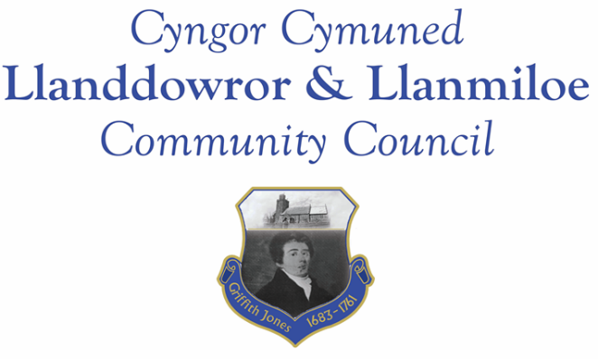
Minutes of the meeting of Llanddowror and Llanmiloe Community Council
Held in Llanddowror Meeting Room, Monday 14th October 2019.
Present: Cllr Phill Pickerskill (Chair), Cllrs Angela Crewes, , Sandra Hewens, David Howells, Gwyn Owens, County Cllr Jane Tremlett. In addition a member of the public was in attendance.

- Apologies for absence. These were received from Cllrs Terence Langdon and Chris Holt. It was stated that Cllr Langdon’s mother had passed away recently – it was agreed that the Clerk should send a letter of condolence.

- Declaration of personal interests. No personal interests were declared..
- Adoption of previous minutes for 9th September 2019. These had been previously circulated. They were reviewed, and agreed as a true record, therefore signed – proposed by Cllr Howells, seconded by Cllr Pickersgill.
- County Councillor’s report.
Cllr Tremlett stated that the budget discussions in CCC for the next financial year had commenced. She also highlighted that the annual toybox appeal had started, and gave some background into how the recipients were chosen. Regarding the broken glass reported in the last meeting, this had been cleared, but since debris and sometimes flytipping kept occurring in this same area, she had requested that the cleansing teams check the area regularly in the future. Two issues were raised locally: the height and spread of the rushes/hedge on the road from St Clears to Laugharne at the turning to New Mill, which was dangerously impeding visibility for traffic. In addition one of the red edge markers on Pocket Lane in Llanddowror was knocked over and needed reinstating. Cllt Tremlett noted both of these and stated she would pass on these issues for resolving.

Cllr Tremlett then left the meeting

- Matters on going from previous meeting:
- Llanddowror water channel. The contractor had been successfully contacted and should be getting it done in the next month.
- Chair plaque. In the absence of Cllr Holt this item was held over to the next month.
- Welsh Water rising main feedback. Cllr Pickersgill was continuing to chase this. From information so far received it appeared that a major sewer replacement programme was needed as a result of infiltration, and also work was required on the pumping main. Some on site investigations had been carried out, but there was no report on the investigations as yet.
- Noticeboards. The Llanddowror one had been treated in the last week. It was reported that the Llanmiloe one would need to be removed for sanding and varnishing – this would be hopefully done in the next month.
- Llanddowror toilets. It was agreed to close these for the winter as last year. The Clerk would inform CCC accordingly.
- Concerns raised with County Cllr in previous meeting. This had been covered in the County Councillor’s report and the ensuing discussion.

- New business:
- Angela Burns AM meeting. Cllr Pickersgill took the meeting through some work he had done comparison mapping the two junctions on the A477. It was agreed to pay the cost of the mapping required to make the case for having a slip-road at the Red Roses junction in the letters to Ken Skates AM and Angela Burns AM. The Clerk would pass this on to the other Councils who had expressed concern about the A477.
- Llanmiloe waste soil dumping. Cllr Pickersgill had arranged a meeting to discuss this on October 24th with the relevant CCC officer.
- Biodiversity summary action plan. The Clerk provided the brief background to this, and circulated the draft action plan. It was agreed this would be reviewed and considered in more detail in the next meeting.
- MoD land ownership meeting feedback. Cllr Hewens and the Clerk had met the relevant Estates Officer and had a positive meeting. She would be drawing up a plan for the ongoing maintenance of the land owned by the MoD, but had stated this might take some time to actually start. She was also shown the Japanese Knotweed that had spread from the MoD land, and would get an eradication plan set up.
- St Clears Station. Cllrs Crewes and Howells had attended this meeting earlier. They reported that St Clears was one of four stations being considered for re-opening in Wales, but that a case had to be made to justify it. St Clears Town Council was leading on this, but requested the help of neighbouring Councils in providing support, dialogue with and feedback from their local communities. The meeting was told it was a long process with many stages and no guarantee of success.
- Wreath purchases. It was agreed to purchase two wreaths as last year and to have them delivered to Cllrs Pickersgill and Hewens. The Clerk would arrange this.
- One Voice Wales area meeting, and motion put forward for the AGM. The Clerk gave a very brief summary of the meeting, and stated that the motion put forward by this Council to the AGM would not be taken forward because it overlapped with representations already being made quite strongly by OVW with the Welsh Government.
- CCC Christmas toybox appeal. This had been briefly mentioned by County Cllr Tremlett. It was agreed to make a donation to this.
- New Councillor applications. The Clerk had received two applications, and responded accordingly. One applicant was present, and provided some personal background and why he would like to become a Councillor. After a brief discussion it was agreed the Council would be delighted to co-opt him. He duly signed his declaration, and then those present welcomed Cllr Nigel Hodson onto the Council.

- Financial report. This had been circulated prior to the meeting. It was reviewed and considered acceptable. The bank mandate was ready for signing and verification, but this would be deferred to the next meeting in the absence of the relevant Cllrs.
Invoices and payments agreed:

Clerk salary and expenses for October.
Clerk tax due for October
Dwr Cymru - £9.50 (direct debit) October
Swalec – (direct debit) £59.40
Llanddowror Village Association - £50.00 for fireworks
Llanmiloe Community Association - £50.00 for fireworks
Royal British Legion - £50.00 for two wreaths
CCC – Toybox Appeal - £50.00 donation.
In addition the Council agreed unanimously to pay for the required mapping work for the case for a sliproad on the A477 to be put to the Welsh Government – approx £100.00.

- Correspondence:
- Natural Resources Wales engagement workshop.
- Launch of Moving Rural Carmarthenshire Forward.
- Police and Crime Commissioner – CCTV event.
- Publicity for flu jabs.

- Planning matters:
- Application granted W/39286. Submission of reserved matters (appearance, landscaping, scale) for outline planning permission W/38336 on plots 24 and 25. 24 Dan y Bryn, Pendine.
- Application W/39435. Reserved matters – appearance, landscaping and scale. Plot 20, old MoD site, Marsh Road, Llanmiloe. Relates to planning application W/38336 which has already been decided. There were no objections
It was pointed out that theabove two applications refered to the same site with different terminology.
- Application W/39585. Discharge of conditions: submission of photographic survey and details of the design and materials for windows and doors on application W/38569: Brook House Farm – conversion of barns to holiday let accommodation etc. There were no objections.

- Councillors reports and matters for next meeting:
There was a query as to the timetable for the CCC lights replacement project – the Clerk would make enquiries.

It was suggested that the Council provide more formal ‘welcome to’ signs at the entrances to the villages. Information and examples would be passed to the Clerk and investigations made into possible styles, costs etc.

Cllr Pickersgill mentioned and passed around an image of the slate plaque which had recently been installed at the church entrance, commemorating Griffith Jones. It was suggested that copies of it could be displayed within the Meeting Room.

- Date and venue of next meeting.
This was agreed to be on 11th November, in Llanmiloe Resource Centre, starting at 7.00pm

There being no other business, the meeting was closed at 9.15pm.

