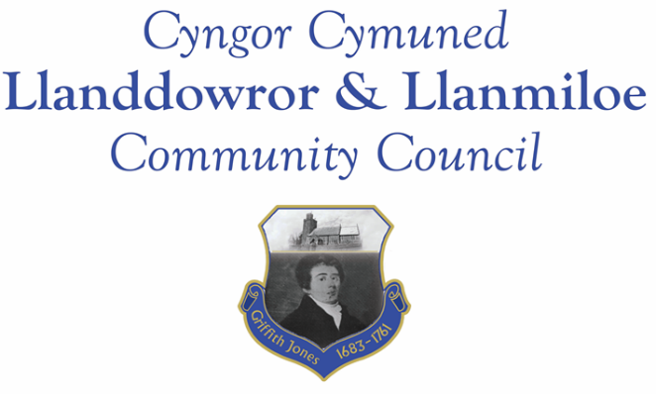
NOTICE OF MEETING

To All Members of Llanddowror & Llanmiloe Community Council.
I hereby summon you to attend the meeting of the Council, starting at 7.00pm on Monday 13th November 2023, for the transaction of the business outlined in the agenda below.
This meeting will be held in Llanddowror Meeting Room.

Vicky Mitchell – Clerk

Agenda

1. Apologies for absence.

2. Declaration of personal and prejudicial interests.

3. Questions from members of the public regarding items on the agenda.

4. Adoption of previous minutes of meeting held on 9th October 2023.

5. County Councillor’s report, including on matters raised in previous meetings, specifically a) grit containers; b) Report on 3 Llanmiloe matters sent 23-10-23. Queries to the County Councillor raised by those present.

6. Clerk’s report.

7. Matters ongoing from previous minutes requiring discussions or decisions, not covered above:
- Meeting Room, including decorating update and any updates on future potential use of the facility.

8. New business.
- Consider whether this Council wishes to take on verge cutting in the community. If so,will require getting indicative prices for verge cutting from April 2024 onwards, if CCC (landowner) agrees. Discuss impact upon precept. Agree precisely which verges to include.
- Consider further actions if any after feedback received on the three Llanmiloe matters report.
- Consider proposal to close Laugharne surgery and decide what actions this Councl wishes to take.
9. Financial Report
- Current financial situation: Financial report appended to agenda.
- Income received: .

- Invoices to pay:
- Clerk monthly salary and expenses – November.
- HMRC monthly payments – November.
- Dwr Cymru - £50.00 (direct debit) per month.
- British Gas Lite – variable direct debit each month – £25.64 in November
- BLC – toilet cleaning November - £80.00.

10. Significant correspondence.
- One Voice Wales training opportunities.
- OPCC invitation for Cllrs to open session at HQ.
- Carmarthenshire Enlghtnment Project – book published, conference on 11-11-23.
- Ombudsman list of advice agencies published.
- Mid and West Wales Fire and Rescue Service consultation – 2040 plan.

Any other correspondence received prior to meeting but after the date of publication of this agenda will be brought to the attention of the meeting for consideration.

11. Planning matters.

PL/06799 Change of use from a disused chapel into a one bedroom home. Demolition of the existing substandard porch which will be rebuilt to the same design but extended to the rear to accommodate a small bathroom - Elim Chapel House, St Clears, Carmarthen, SA33 4JA . Application received 30-10-2023.

PL/06404. Construction of detached garage and equipment Store (Resubmission of PL/05396) Cnwc, Llanddowror, SA33 4HN. Received 7-8-2023. Householder granted 4-10-2023

Any planning received prior to meeting but after the date of publication of this agenda will be brought to the attention of the meeting for consideration.

12. Councillors’ reports for information or items for next meeting.

13. Date of next meeting – 11th December 2023.
~~~~~~~~~~~~~~~~~~~~~~~~~~~~~~~~~~~~~~~~~~~~~~~~~~~~~~~~~~~~~~~~~~~~~~~~~~

Meeting dates for 2023-2024:

11th December 2023
8th January 2024 12th February 2024
11th March 2024 8th April 2024
13th May 2024 10th June 2024
9th September 2024 14th October 2024
11th November 2024 9th December 2024
Meetings to be either in Llanmiloe Resource Centre, with hybrid access via Zoom provided as required, or in Llanddowror Meeting Room, or fully via Zoom.

