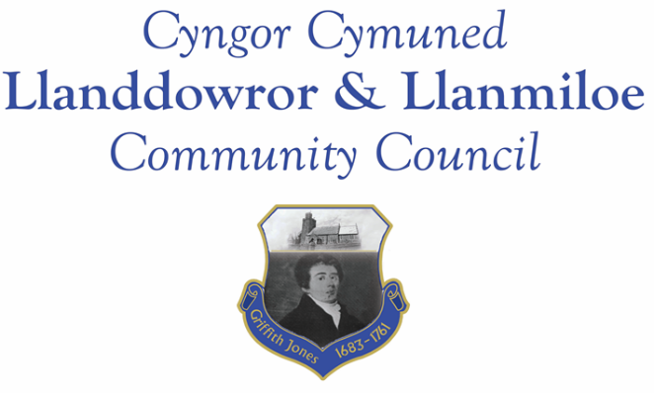

NOTICE OF MEETING

To All Members of Llanddowror & Llanmiloe Community Council.
I hereby summon you to attend the meeting of the Council, starting at 7.00pm on Monday 3rd October 2022, for the transaction of the business outlined in the agenda below.

Vicky Mitchell – Clerk

Agenda

1. Apologies for absence.

2. Declaration of personal and prejudicial interests.

3. Questions from members of the public regarding items on the agenda.

4. Adoption of previous minutes – 13th June 2022 and 18th August 2022.

5. County Councillor’s report, including on matters raised in previous meetings, specifically:
- Speed management issues: Llanddowror warning signs request; Llanmiloe speed bumps near school; Llanmiloe signage in village inadequate especially at night.

6. Clerk’s report.

7. Matters ongoing from previous minutes requiring discussions or decisions, not covered above:
- Community projects – receive any new information on specific projects – those agreed were. Llanmiloe one-off pill clearance; Llanddowror seating; play equipment in both communities, Llanddowror Pocket Park tree management.
- Llanddowror Old Café site – consider latest information on enforcement process and agree next steps to take that are available to this Council.
- Council vacancies – consider suitable candidates – 1 North Ward, 2 South Ward.

8. New business.
- Council draft training policy – review and adopt if acceptable.
- Safer Routes in Communities – Llanmiloe application.
- Llanmiloe School governor vacancy – to consider nominations for this role.
- Llanddowror seat – ratify decision to replace old rusty seat for H+S reasons.
- Consider wreaths to purchase for Remembrance events in November.
- Llanddowror sandbag containers – consider condition of them, whether to replace any, and potential relocation within village to more suitable places.
- Llanddowror Meeting Room – pipe leak requiring plumber; consider retaining open all year; consider donations box.
- Review Financial Regulations of the Council.
- Clerk – laptop report – consider replacement of laptop,
9. Financial Report
- Current financial situation. Financial report appended to agenda.
- Income received: £4166.67 Precept second instalment.
- Invoices to pay:
- Clerk monthly salary and expenses – July, August, September. The July and August payments have already been made as per contract but are noted here for information.
- BLC – toilet cleaning June, July, August, September - £80.00, £64.00, £64.00, £102.49. Note – as agreed in June 2022 these contracted payments have been made and are noted here for information.
- HMRC monthly payments – July, August, September. The July and August payments have already been made as per contract but are noted here for information.
- Dwr Cymru - £20.50 (direct debit) per month.
- Swalec - £36.23 on 29-7-22 – direct debit.
- One Voice Wales membership - £137.00. Previously omitted from payments due.

10. Significant correspondence.
- One Voice Wales training opportunities.
- Welsh Govt – fairer Council Tax consultation – open until 4-10-22.
- Welsh Government – legislation on speed limit changes, starting 2023.
- Correspondence regarding A477 Red Roses junction – for information.
- Invitation to St Clears RBL 85 years exhibition

Any other correspondence received prior to meeting but after the date of publication of this agenda will be brought to the attention of the meeting for consideration.

11. Planning matters.

PL/04407 - Proposed new 3 storey residential dwelling development - Plot 5, Land adjoining Wood End, Dan Y Bryn, SA33 4UG. Application registered 04-08-2022.

PL/04502 - Construction of house - 14 Dan Y Bryn, Pendine, Carmarthen, SA33 4EZ Application registered 12-09-22.

PL/04456 - Proposed erection of a single new dwelling on an existing residential development - Land Adjacent to Wood End/Dukes Meadow, Pendine, Carmarthen, SA33 4UG Application registered 13-09-22

PL/04094 - Extension to dwelling house with link to form additional bedroom - Honeywell Barn, Laugharne, Carmarthen, SA33 4RA. Consultation from 31-5-22. Application granted 19-07-2022.

PL/04215 - Proposed demolition of conservatory and creation of new sun room - Parc Cynog, Laugharne, Carmarthen, SA33 4PY Application registered 16-06-2022. Application granted 27-07-2022.

Any planning received prior to meeting but after the date of publication of this agenda will be brought to the attention of the meeting for consideration.

12. Councillors’ reports for information or items for next meeting.

13. Date of next meeting – November 14th 2022.

~~~~~~~~~~~~~~~~~~~~~~~~~~~~~~~~~~~~~~~~~~~~~~~~~~~~~~~~~~~~~~~~~~~~~~~~~~

Meeting dates for 2022-23:

May 9th 2022 June 13th 2022 October 3rd 2022 November 14th 2022 December 12th 2022
January 9th 2023 February 13th 2023 March 13th 2023
April 10th 2023
Meetings to be based in Llanmiloe Resource Centre, with hybrid access via Zoom provided as required.

